

Health

&

Safety Handbook

Policy Folder:

Health

&

Safety

English as an
Additional Language
(
EAL)

Standards and Guidance

Practice and Standards

Contents
Section 1. Introduction 3
Section 2. Purpose 4
Section 3. Terminology 4
3.1 Bilingualism 4
3.2 New Arrivals 5
Section 4. Cultural Competence 5
Section 5. Working with Families 6
Section 6. Interpreters 8
Section 7. Assessment 9
Section 8. Staffing 10
Section 9. EAL Students with Additional Needs 10
Section 10. Supporting EAL Pupils in School 14
Section 11. Inclusive Communication Standards & Guidance 16
Section 12. Educational Outcomes for EAL Pupils 16

Section 1. Introduction

The UK is a multicultural society. Its citizens speak many languages, have different beliefs and religions and different cultural practices. Language is a vital component of the transmission of culture from one generation to the next in communities. Without an understanding of their home language, children and young people may have difficulty understanding the nuances of concepts, beliefs and ideas associated with their culture which can be a disadvantage.

Not supporting pupils who are bilingual or learning English for the first time is discriminatory, which is prohibited by the United Nations Convention of Children Rights. For this reason, it is a requirement for all schools in the UK to provide the necessary resources and to accommodate the needs of all children and young people for whom English is an Additional Language (EAL), so that these pupils can achieve the best possible outcomes. OFG is committed to supporting all pupils equitably and this includes pupils who are bilingual or learning English as a second language. Schools therefore have a responsibility to provide a welcoming multicultural environment and provide the necessary support to bilingual pupils and those learning English for the first time.

Children and young people who are learning English as an Additional Language (EAL) may need targeted support as there are a significant number who may have special educational needs, and a high percentage have specific Speech, Language and Communication Needs (SLCN). For this group, early identification is key to ensuring that they receive the right support.

Bilingualism is not a cause of underlying communication and interaction differences, traits, difficulties and needs and there is little evidence to suggest that the prevalence of SLCN is greater in children who are bilingual or learning English for the first time. When there are communication differences, traits, difficulties and needs, then these will be present in all the languages understood and used by the child or young person. It must always be remembered that there are benefits to bilingualism, for example bilingual pupils may have greater phonological awareness skills which can support the development of literacy skills.

Section 2. Purpose

The purpose of this document is to provide information on:
1 | Terminology
2 | The concept of Cultural Competence
3 | Requirements when supporting EAL pupils
4 | Working with families and carers.
5 | Working with interpreters.
6 | Assessment.
7 | Staffing requirements.
8 | Supporting EAL pupils in school.
9 | Additional complex underlying communication and interaction needs.
10 | Inclusive Communication Approach
11 | Vulnerability of EAL pupils and risks.

Section 3. Terminology

To be informed, it is important to understand the terms that are used when referring to groups for whom English is not their first language.

3.1 Bilingualism

Bilingualism is the ability to understand and/or use two or more languages and this includes sign language. There is no reliable data on the number of bilingual speakers living in the UK, but in 2012 The National Association for Language Development in the Curriculum (NALDIC) published information from the School Census in England, and this indicated there were 18 languages spoken by more than 10,000 pupils.The accepted term for the language used as the first language is “mother tongue or home language”. The term “simultaneous bilingualism” is when a child is exposed to two or more languages when in different environments and with different people. Sequential bilingualism is when a child is exposed to one language and then a second language. A bilingual individual will switch from one language to another depending on the context, situation, person and place. It should never be recommended to parents / carers that their “mother tongue / home language” should be abandoned, but they can choose for this to be the case.

3.2 New Arrivals

The term New Arrivals refers to all individuals or families who have moved to a new location for different reasons and certain terms describe their status.

- Immigrant - a person who has moved to another country to take up permanent residence, usually for reasons of employment, education or family connection. They have relevant government authorisation and accompanying documentation.
- Illegal Immigrant – a person who has moved to the UK but does not have the relevant government authorisation and accompanying documentation.
- Refugee: a person who has been forced to leave a country in order to escape war, persecution of a natural disaster.
- Asylum seekers: a person who has left a country and is seeking protection in another country from persecution or human rights violations but has not been granted refugee status.
- Economic Migrants: a person who has chosen to move to a different place to seek better economic opportunities e.g. employment or better quality of life.

Section 4. Cultural Competence

The term cultural competence is the ability to effectively and respectfully interact with individuals and communities with diverse backgrounds, cultures and beliefs. It involves using this knowledge to foster and develop relationships and facilitate communication to ensure equity and inclusion. Essentially, it is about recognising and valuing differences among people and adapting approaches to meet their individual needs. Demonstrating cultural competence entails:
• | Recognising and valuing difference and accepting diversity.
• | Developing awareness of personal cultural beliefs and impact on feelings towards other cultures.
• | Developing awareness of the attitudes of other cultures relating to different topics e.g. education, disability and health.
• | Accepting, respecting and acknowledging all cultural differences e.g. when greeting socially.
• | Demonstrating a commitment to forming trusting relationships.
• | Making sure that all information is available in the language used by individuals and communities.

In schools, cultural competence entails respecting the beliefs, religion and cultural norms, of EAL pupils

and their families / carers whilst at the same time providing clear and evidence-based advice, guidance, support, assessment, teaching and intervention.

There are different types of EAL education:
Dual Language Programmes | • | Provide teaching in both the home (first) and second language.
Immersion Programmes | • | Involves exposure to the second language by using it as the primary language for teaching and instruction.
Content and Language Integrated Learning | • | Integrated language learning when teaching subjects.
The Bell Foundation provides guidance to schools on how to support EAL pupils and this can be accessed using the link: EAL Guidance - The Bell Foundation

PEaCH (Preserving and promoting Europe's cultural and linguistic heritage through empowerment of EAL children and families) is an EU-funded project that aims to support EAL children and their families. It provides resources, guidance, and support to help parents and maintain and maintain and develop children's multilingual skills, particularly focusing on the 24 official EU languages.

Section 5. Working with Families

Working closely with parents / carers of all pupils is key to ensuring their wellbeing and the achievement of the best academic outcomes. Parents / carers of pupils who are English as an Additional Language (EAL) learners may struggle to be actively involved for different reason e.g. they may not speak English or have attended school. For this reason, schools need to consider on an individual basis:

• | Parents exposure to and experience of school.
• | Language(s) spoken.
• | Levels of literacy in their home language.
• | Levels of English language proficiency.
• | Capacity to attend and take part in meetings.
• | Fear of sharing personal information with professionals.
• | Beliefs and practices relating to culture and communication.
• | Expectations and wishes in respect of their child or young person’s education.

When supporting parents / carers of pupils who are English as an Additional Language (EAL) learners, it is important to take a whole school approach so that all staff understand the barriers there might be to their involvement. This will entail providing adequate training for staff teams.

To enable parents / carers of EAL learners to be involved it is important to ensure that the information is accessible. Consideration therefore must be given to:

• | Whether interpreters are required during meetings.
• | Whether documentation needs to be translated and if the use of images would add context and meaning.
• | Whether information available to all parents is accessible to them in a format they will understand.
• | Whether support is needed from members of staff and / or parents or staff who speak their home language.
• | Whether the channels for sharing information about their child on a daily / weekly basis are appropriate.
• | Whether other family members who speak English could support (note: it is not appropriate to use the siblings of a child as a translator and so this should be avoided)

When working with these parents / carers it is essential to explain that exposure to both their home language and English is essential for development. This is important as abandoning their home language would mean they would need to learn it at a later stage. It is however the parents / carers choice whether their child or young person is mono or bilingual when they are an adult.

Further information on how to support parents / carers of EAL learners can be accessed via the charity The Bell Foundation. The Bell Foundation - Changing lives and overcoming exclusion through language education

Section 6. Interpreters

Interpreters translate for individuals or groups conversing in different languages. They also translate written language. When supporting OFG services, interpreters may be required to act as both interpreter and translator. In the UK, interpreters are regulated by the National Register of Public Service Interpreters (NRPSI) NRPSI -National Register of Public Service Interpreters. In the
UK, sign language interpreters are registered by the National Registers of Communication Professionals working with Deaf

and Deafblind people (NRCPD) National Registers of Communication Professionals working with Deaf and Deafblind People (NRCPD) .

Working with interpreters is crucial to ensuring that the needs of EAL pupils are being met equitably in schools, and it enables parents / carers to be fully involved in the decision-making process in respect of their education and the support they receive.

The services of an interpreter may be required at different stages or throughout a pupil’s school journey. Interpreters can support assessments, facilitate day-to-day communication with parents / carers, support them at meetings and help them understand key documentation. They can also support schools to help parents / carers understand the importance of continuing to develop skills in their home language.

Siblings under 18 years of age, other family members and friends, or untrained volunteers should never serve as interpreters as stated in the National Council on Interpreting in Health Care, 2011 standards.

When working with interpreters:
• | Make sure they understand exactly what is expected and this is documented.
• | Make sure they have signed a document which outlines the need for confidentiality.
• | Prepare in advance any additional resources that may be required e.g. visuals, for meetings and assessment sessions.
• | Be mindful of the importance of always facing and directing speech towards the pupil, parent / carer and not through the interpreter.
• | Prepare questions that you want the interpreter to ask in advance.

In the UK, interpreter services for English as an Additional Language (EAL) pupils is funded through a combination of local authority funding, schools, grants or other services. Further information about how local authorities allocate funding for EAL pupils can be accessed using the link. Schools block funding formulae 2024 to 2025: Analysis of local authorities' schools block funding formulae - GOV.UK

Section 7. Assessment

Assessing the needs of pupils for whom English is a second language is essential and should involve gathering information on their ability in the foundation skills (listening, shared attention and

engagement, their receptive understanding, their communication and interaction skills and their literacy skills. The Bell Foundation have developed an EAL assessment framework for UK schools to use, which has separate sections for the Early Years Foundation Stage (EYFS), primary and secondary. Further information about how to undertake assessment with EAL pupils use the link: EAL Assessment Framework - The Bell Foundation

The services of an interpreter should always be employed when assessing an EAL pupil if the aim of is to explore the presence of underlying specific communication and interaction delay, difference, difficulties or disorder. For those pupils that are bilingual, assessment should be in all languages. Interpreters should be involved throughout the assessment period. It is a legal requirement to provide equitable services (Equality Act, 2010; United Nations Convention on the Rights of the Child, Article 2) to EAL pupils and so this overrides the cost of employing the services of an interpreter when assessing an EAL pupil.

Some EAL pupils may have underlying Special Education Needs (SEN). When this is suspected, it is important to take a multi-disciplinary approach with the education and clinical teams working together and involving outside agencies when required. When a specialist communication assessment is required the speech and language therapists (SaLT) should be involved. Speech and language therapists, when involved in the assessment of an EAL pupil, should refer to the guidance outlined by the Royal College of Speech and Language Therapists. Bilingualism guidance | RCSLT .When completing an assessment, they must be mindful that standardised assessment tools should not be used as they are not normed for this group and do not take account of cultural and other differences.

Section 8. Staffing

Schools supporting EAL pupils need to be able to accommodate those that are learning English for the first time, those that already speak some English and those that have underlying communication differences, difficulties traits and needs. Staffing needs will vary greatly from one school to another but there may be a need to have:

• | Specialist EAL teachers.
• | Additional learning support / teaching assistants.
• | Members of staff who are fluent in a particular language(s).
• | Clinicians who are fluent in a particular language.

The National Subject Association for EAL website Organisational structure - NALDIC provides useful

information and guidance on EAL specialists and support staff in schools staff Principles.cfm. Funding received specifically for EAL learners can be used to employ staff, provide resources, and support EAL provision. Headteachers should liaise with the local authority to find out how the EAL funding formula applies to their EAL pupils.

Section 9. EAL Students with Additional Needs

There are four key stages in the identification of EAL pupils with special education needs and how to support, which is based on the Graduated Approach (Assess, Plan, Do, Review):

1 | Initial screening / baseline assessment
2 | Request for specialist assessment (multi-disciplinary approach)
3 | Further information gathering and working with family / carers.
4 | Initiating and embedding a graduated response (plan, do, review)

The Bell foundation in their framework provides clear guidance on what is required at each stage in the process.

• | The action needed
• | Which members of staff should be involved.
• | The roles of key stakeholders
• | The transition process
• | Who to inform regarding findings of assessment and the plan to meet needs.
• | What outcomes can be expected and achieved.

Further information on the process can be accessed using the link EAL Assessment Framework - The Bell Foundation. EAL pupils with special education needs may be linked to underlying communication and interaction differences, traits and / or specific difficulties. Examples of underlying communication and interaction needs that EAL pupils may have been listed in the table below:

• | Some may be at the early stages of developing communication skills
• | Some may have cognitive impairment, other diagnoses and / or a neurodivergent profile.
• | Some may have processing difficulties
• | Some may have specific speech and language disorders (e.g. SSD & DLD & dysfluency)
• | Some may be speaking and some non-speaking,
• | Some may be diagnosed with Selective Mutism
• | Some may have experienced adversity and trauma.

The Bell Foundation flowchart below gives an overview of the process for applying a graduated approach.
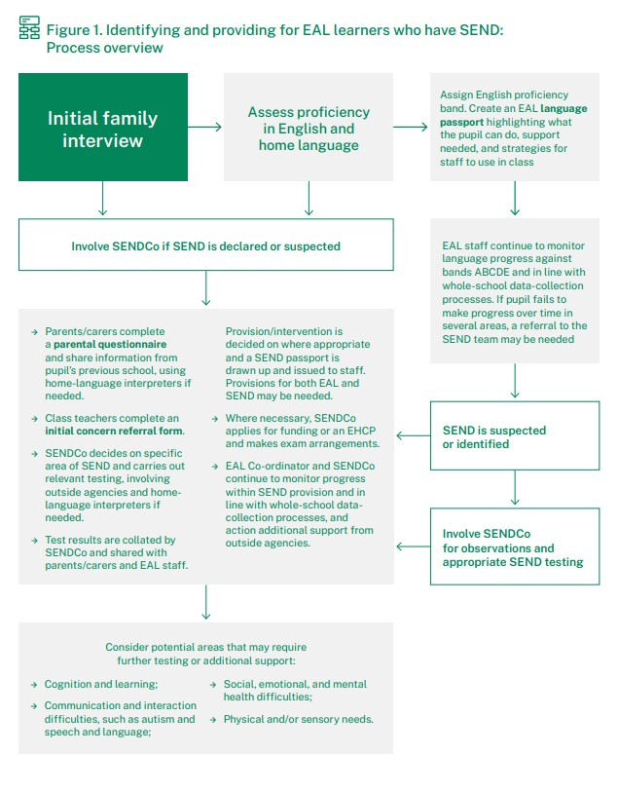

It is important when assessing EAL pupils for specific communication and interactions differences, traits and difficulties that the presence of a biomedical condition that could account for these must be ruled out. Determining the presence requires a multidisciplinary team assessment approach, and this will involve working alongside interpreters and other external professionals. The results of this assessment will guide the diagnostic decision regarding any specific disorder and the support plan required. EAL pupils may need a more targeted approach, and parents / carers may need higher levels of support.

Speech and Language Therapists should refer to RCSLT guidance and factsheets when supporting
EAL pupils who present with underlying specific communication needs. Home | RCSLT

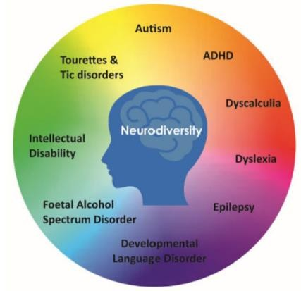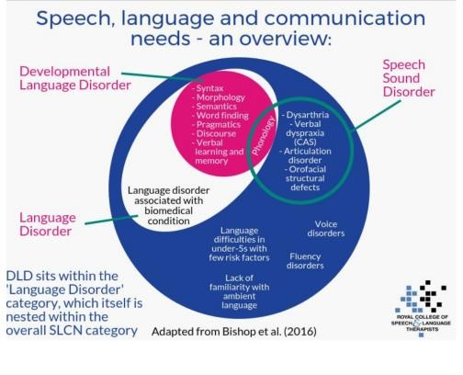

As for all pupils in OFG with complex profiles, the role of staff teams when supporting EAL pupils with additional needs is to promote inclusion and support them to be able to process with understanding and communicate effectively to the best of their ability by whatever means; this may entail the use of Augmentative and Alternative Communication (AAC) systems.

When supporting this group of EAL pupils it is essential to apply a person centred, strength-based approach and apply neurodiversity affirming and trauma informed practice.

Person Centred, Strength Based, Neurodiversity Affirming and Trauma Informed
Practice
• Understand the importance of building trusting relationships.
• Consider preferences and needs on an individual level.
• Ensure individuals have the communication systems and support they require.
• Listen to the views of the individual, and their parents and carers
• Recognise the potential impact of stress reactions that may result in trauma, for example in response to frequent changes in routine, social situations, or sensory stimuli.
• | Recognise the ways in which individuals are excluded.
• | Be aware of the evidence base for interventions, programmes and approaches.
• | Discuss options for support and intervention with parents or carers and the pupil whenever possible to make them aware of the advantages, disadvantages and current thinking on approaches.
• | Respect the wishes of the pupil and their parents / carers.
• | Focus on harnessing strengths, interests and abilities
• | Identify and agree goals with parents / carers, and pupil whenever possible, which focus on improving quality of life, enabling inclusion, and reducing risk and harm.
• | Demonstrate awareness that if deviating from a manual or modifying the delivery of a named intervention with proven evidence-base, assumptions of efficacy should be confirmed and effectiveness monitored.
• | Provide opportunities to experience positive communication and interaction.

Section 10. Supporting EAL Pupils in School

There are challenges for both EAL pupils and staff teams in schools. There are the language and cultural barriers, but these pupils may have had little prior education, and they may have significant emotional and social needs linked to adversity and trauma. These pupils frequently lack confidence, which can lead to reduced levels of engagement which can then negatively impact on progress.

When supporting EAL pupils in school it is essential to make sure that the environment is welcoming, all staff understand the needs of EAL pupils and that approaches and strategies are utilised to promote language development.

Awareness | • | Be aware of the challenges that EAL pupils face and show understanding and empathy.
 | • | Be aware of and respect cultural differences.
 | • | Be aware that EAL pupils may have additional underlying differences, difficulties and needs.
 | • | Work with parents / carers and collaborate with other team members e.g. clinicians.
Communication | • | Support visually i.e. make use of images (photos / symbols) and diagrams.
 | • | Break information down visually e.g. use numbered checklists and graphics to support sorting and grouping.
 | • | Use visual schedules and sequences to provide structure, routine and support completion of tasks independently.
 | • | Focus on core vocabulary, simplify language and use repetition.
 | • | Make use of word banks and picture dictionaries.
Supporting Language Development | • | Encourage use of their home (first) language to help them process information in English.
 | • | Provide scaffolding e.g. use sentence starters and forced choices.
 | • | Provide opportunities for peer interaction e.g. pair EAL pupils with English speakers in shared activities.
 | • | Pre-teach core vocabulary prior to lessons about a specific topic.
 | • | Provide opportunities to practice speaking English in situations they will experience success.
 | • | Provide opportunities for EAL pupils to contribute to lessons.
 | • | Give positive feedback on progress and celebrate successes to build their confidence and self-esteem.
Assessing and supporting individual needs. | • | Developing individualised learning plans that take account of language differences.

Useful information for teachers and other staff teams is available on the NALDIC, the Bell Foundation and the EAL Hub Websites.
NALDIC | EAL National Subject Association
Free EAL Teaching Resources - The Bell Foundation
EAL Strategies and Great Ideas - The Bell FoundationEAL Hub

Section 11. Inclusive Communication Standards & Guidance

All the information in the other four sections of the Inclusive Communication Framework applies to EAL pupils with and without additional complex needs.

Inclusive
Communication
Multimodal
Communication
Standards and
Guidance
Document
Pupil Voice
Standards and
Guidance
Document
Augmentative
and Alternative
Communication
(
AAC
)
Standards and
Guidance
Document
Communication
Friendly
Environments
Standards and
Guidance
Document
English as an
Additional
Langauge (EAL)
Standards and
Guidance
Document

Use the link to access the Standards and Guidance documents and other resources on SharePoint.
Outcomes First Group Resources - Inclusive Communication - All Documents
Outcomes First Group Clinical Resources - Inclusive Communication - All Documents

Section 12. Educational Outcomes for EAL Pupils

The Education Policy Institute and the Bell Foundation published a report on the educational outcomes of EAL Pupils Educational Outcomes of EAL Children - Education Policy Institute. This highlighted large attainment differences and the need for an additional premium to be added to the national funding formula so that schools can provide the additional support required.

To improve outcomes for EAL pupils it is important to:

• | Create inclusive Communication Friendly environments.
• | Apply the cyclical ‘Graduated Approach’ (assess, plan, do, review)
• | Provided informed targeted support and measure outcomes.
• | Develop strong relationships with families and communities.
• | Apply a whole school approach.

In addition to the risk of under achievement, EAL pupils may be at higher risk of social isolation and bullying. They may also not be able to share information with others when they need help, are feeling excluded and are experiencing bullying. Schools need to be mindful of this and ensure that additional measures are in place to ensure integration and monitor.



