




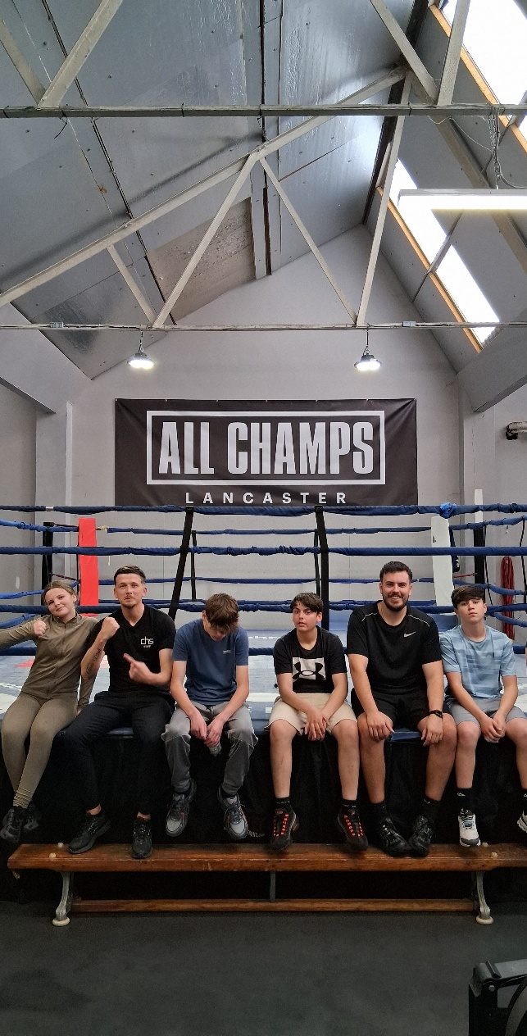
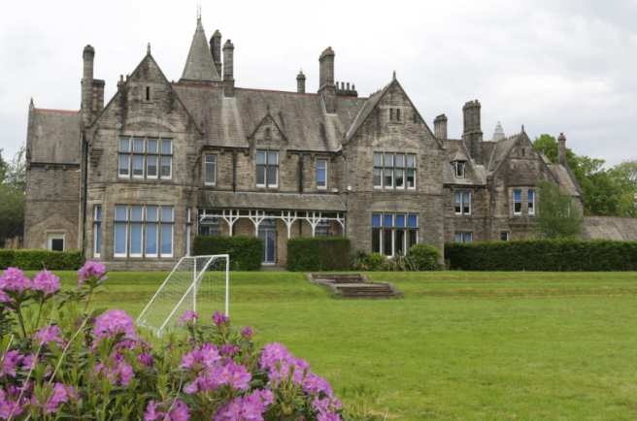
SUMMER TERM
2026
THIS SUMMER TERM, OUR PUPILS AND STAFF HAVE ACHIEVED SO MUCH TOGETHER. THROUGH TEAMWORK, DEDICATION AND RESILIENCE, WE HAVE PROVIDED ENRICHING LEARNING EXPERIENCES, CELEBRATED INDIVIDUAL SUCCESSES, AND CONTINUED TO SUPPORT EVERY PUPIL TO THRIVE BOTH ACADEMICALLY AND PERSONALLY. WE ARE INCREDIBLY PROUD OF ALL THAT WE HAVE ACHIEVED AS A SCHOOL COMMUNITY.

SEE THE SPECIAL AWARD ONE OF OUR BRILLAINT STUDENTS GAINED

SEE HOW OUR POST 16 TRANSITIONS IS GOING

JOIN US IN EXPLORING OUR PE DEPARTMENT

BELIEVE ☆ INSPIRE ☆ ACHIEVE
CROOKHEY HALL SCHOOL
IN THIS TERM’S
NEWSLETTER:
PAGE 3: SUBJECT SPOTLIGHT
PAGE 4:SCHOOL THERAPY TEAM
PAGES 5&6: CURRICULUM NEWS
PAGE 7: VISITORS
PAGE 8: SPECIAL PUPIL AWARD

A MESSAGE FROM THE HEAD
As we reach the end of another successful academic year, I would like to take a moment to reflect on what has been a truly fantastic Summer Term at Crookhey Hall School.
Throughout the term, our pupils have continued to demonstrate resilience, determination and enthusiasm in everything they do. From exciting educational visits and community learning opportunities to creative curriculum projects, sporting activities and enrichment experiences, our pupils have embraced every opportunity to learn and grow.
We have seen pupils develop their independence, build confidence, strengthen friendships and achieve personal goals both inside and outside the classroom. Whether participating in outdoor education, vocational learning, life skills activities, careers experiences or whole-school events, our young people have represented Crookhey Hall School with pride.
None of this would have been possible without the unwavering commitment, care and dedication of our staff team. Every day, staff go above and beyond to support our pupils and provide the nurturing environment that enables them to succeed. I would like to thank each member of our school community for the positive difference they make.
As we celebrate another year of achievement, we also say goodbye to some of our pupils as they move on to their next chapter. We wish them every success for the future and know they will carry the values of Crookhey Hall with them.
Jane Husbands

Thank you to all our families for your continued support throughout the year. I hope you enjoy reading about some of the wonderful experiences and achievements from this term and wish everyone a safe, happy and restful summer break.

Jane Husbands
Headteacher


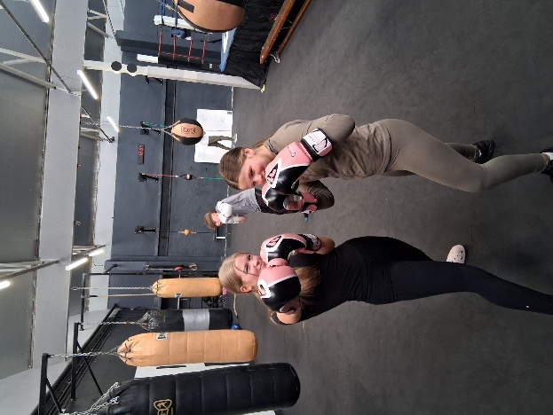
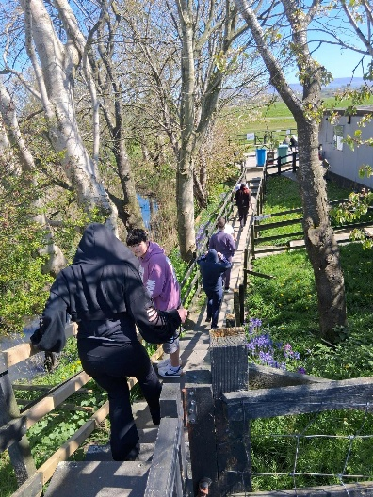
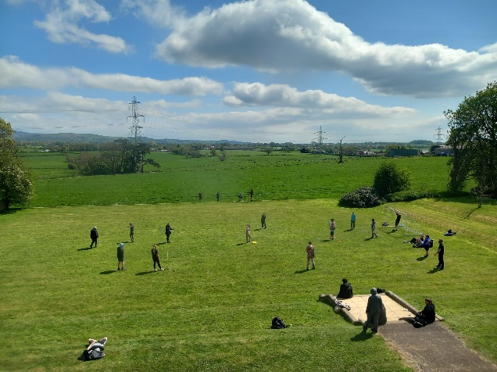
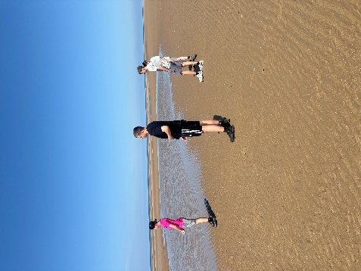
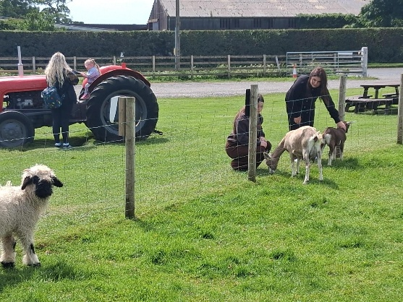
IN PE, PUPILS LEARN HOW TO:
- DEVELOP FITNESS, STRENGTH AND STAMINA
- WORK EFFECTIVELY AS PART OF A TEAM
- BUILD RESILIENCE AND PERSEVERANCE
- IMPROVE COORDINATION, BALANCE AND AGILITY
- DEVELOP CONFIDENCE ANS SELF-BELIEF
SUBJECT SPOTLIGHT
PUPIL VOICE;
"PE IS MY FAVOURITE LESSON BECAUSE I GET TO CHALLENGE MYSELF AND TRY NEW THINGS."
"I ENJOY SEEING HOW MUCH I IMPROVE EACH WEEK."

WE ARE INCREDIBLY PROUD OF THE EFFORT, RESILIENCE, AND DEDICATION OUR PUPILS SHOW FOR PE AND TEAM SPORTS BOTH INSIDE AND OUTSIDE OF THE CLASSROOM.
MANY PUPILS WHO STRUGGLE IN TRADITIONAL CLASSROOM SETTINGS THRIVE IN OUR PE LESSONS. THE PRACTICAL NATURE OF THE SUBJECT ALLOWS THEM TO EXPERIENCE SUCCESS, BUILD SELF-ESTEEM, AND UNDERSTAND HOW TO LIVE A HEALTHY LIFESTYLE.
AT CROOKHEY HALL, PE IS ABOUT FAR MORE THAN SPORT – IT IS ABOUT BUILDING CONFIDENCE, PROMOTING WELLBEING AND DEVELOPING THE LIFE SKILLS THAT HELP OUR PUPILS BELIEVE, INSPIRE AND ACHIEVE.

P.E
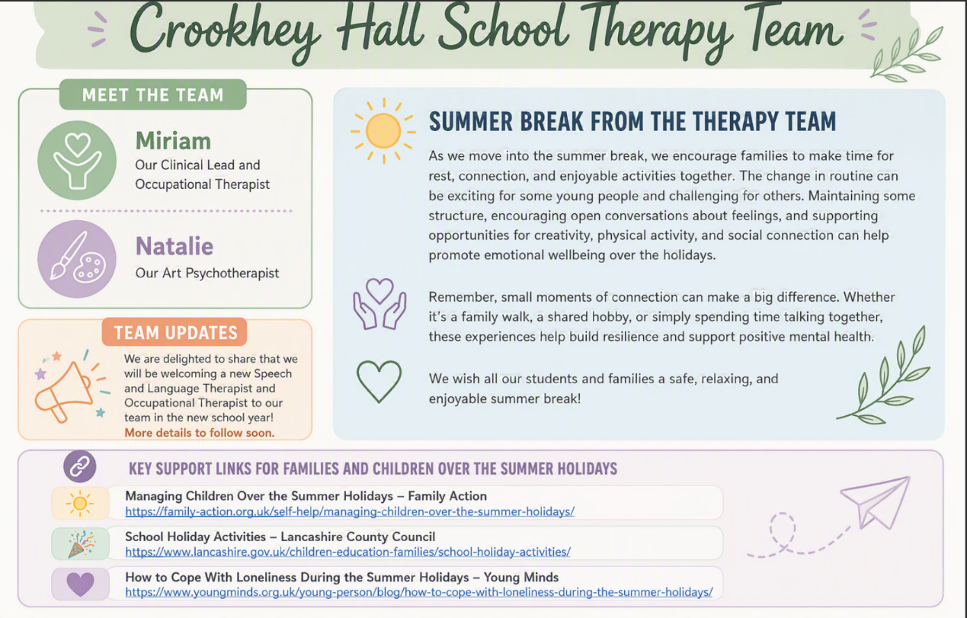
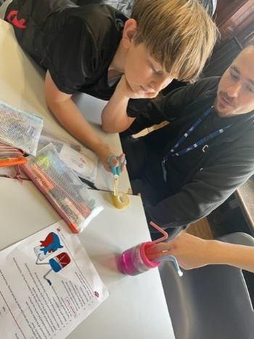
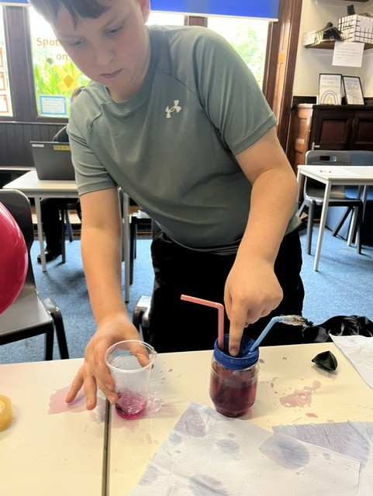
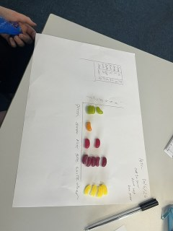
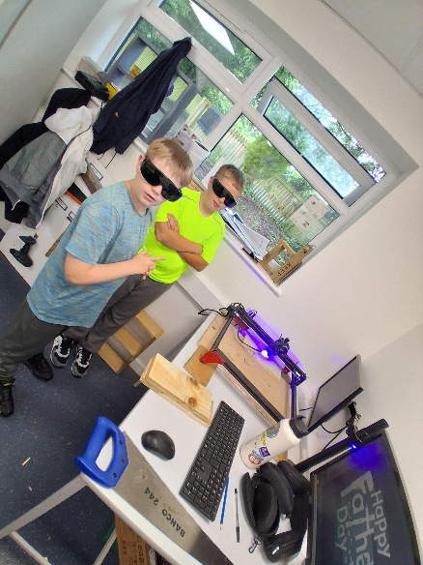
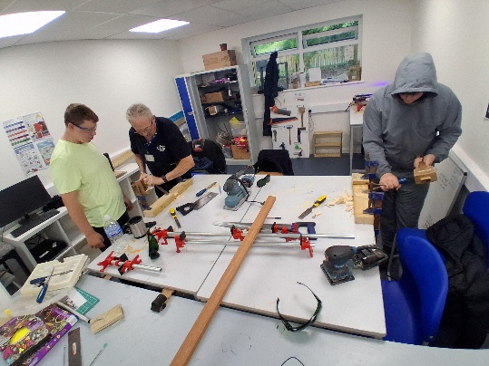
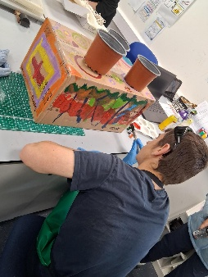
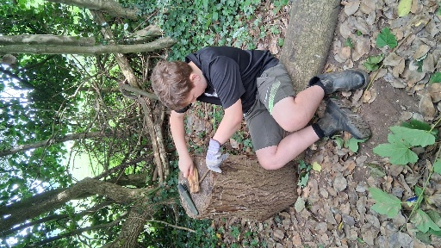
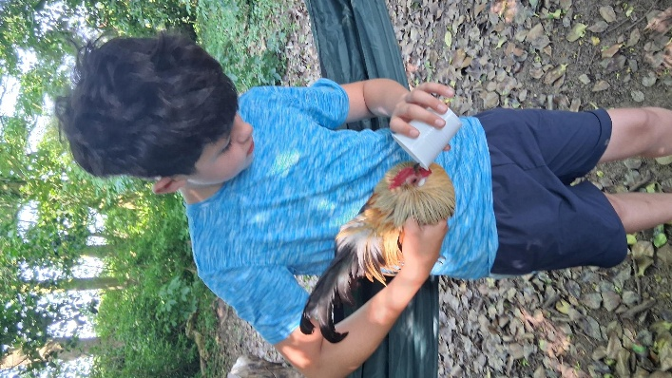
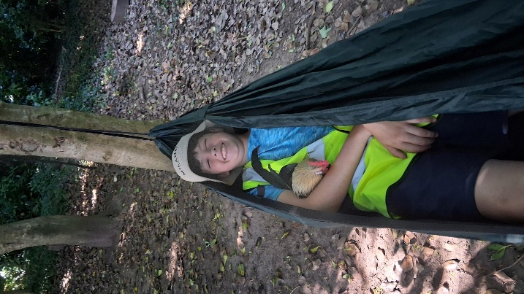
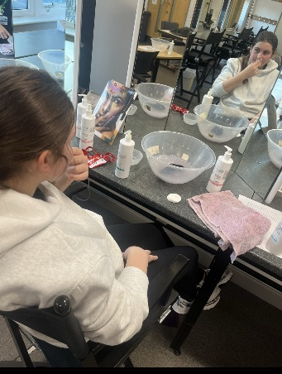
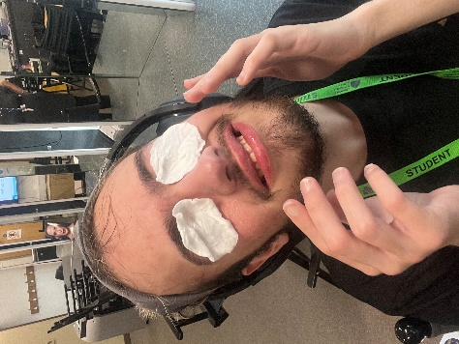
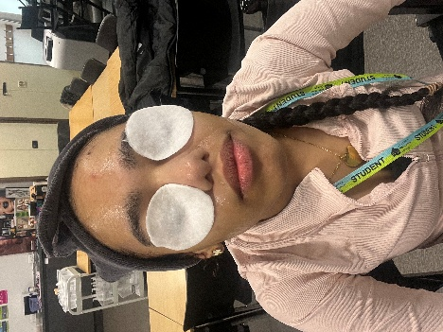

OUR SCHOOL THERAPY TEAM
DURING SCIENCE THIS TERM, PUPILS HAVE BEEN LEARNING ABOUT THE HEART AND HOW IT PUMPS BLOOD AROUND THE BODY. TO BRING THEIR LEARNING TO LIFE, PUPILS TOOK PART IN A PRACTICAL ACTIVITY WHERE THEY CREATED THEIR OWN DEMONSTRATIONS OF THE HEART’S FUNCTION, HELPING TO DEEPEN THEIR UNDERSTANDING IN AN ENGAGING AND MEMORABLE WAY.
IN MATHS THIS TERM, PUPILS HAVE BEEN DEVELOPING THEIR UNDERSTANDING OF DATA BY GATHERING INFORMATION, PRESENTING IT IN TABLES, AND USING THIS TO CREATE A RANGE OF GRAPHS. A PARTICULAR HIGHLIGHT WAS COLLECTING DATA ON FAVOURITE JELLY BEAN FLAVOURS, WHICH PUPILS THEN ANALYSED AND REPRESENTED VISUALLY.
THE ACTIVITY CONCLUDED WITH AN ENJOYABLE AND WELL-EARNED TASTE TEST, ALLOWING PUPILS TO COMPARE THEIR FINDINGS WITH REAL-LIFE OUTCOMES IN A FUN AND ENGAGING WAY.
IN DESIGN AND TECHNOLOGY THIS WEEK, WITH MR CLARK’S CLASSES WORKING CREATIVELY AND PURPOSEFULLY ON A RANGE OF PROJECTS. PUPILS HAVE BEEN BUSY DESIGNING AND MAKING A NUMBER OF ITEMS TO SELL AT OUR UPCOMING SUMMER FAIR, DEVELOPING BOTH THEIR PRACTICAL SKILLS AND AN UNDERSTANDING OF ENTERPRISE. ALONGSIDE THIS, THEY HAVE ALSO BEEN CREATING THOUGHTFUL FATHER’S DAY GIFTS, SHOWING CARE AND PRIDE IN THEIR WORK. WE ARE PARTICULARLY DELIGHTED THAT ONE CLASS DESIGNED AND PRODUCED A BESPOKE SIGN FOR THE CATERING KITCHEN DOOR, DEMONSTRATING THEIR ABILITY TO APPLY THEIR SKILLS IN A MEANINGFUL, REAL-WORLD CONTEXT.

CURRICULUM
OUR FOREST SCHOOL HAS BEEN HUGELY POPULAR THIS TERM WITH THE WEATHER GETTING WARMER AND PUILS STAYING COOL (AND KEEPING THE CHICKENS COOL TOO)
MR GROOM AND HIS 1:1 HAVE HAD A FANTASTIC AND ENRICHING TERM, TAKING PART IN A RANGE OF MEANINGFUL OUTINGS WITHIN THE LOCAL COMMUNITY. DURING THEIR TIME IN LANCASTER, THEY DEMONSTRATED KINDNESS AND SOCIAL RESPONSIBILITY BY SUPPORTING AN ELDERLY COUPLE WITH PAYMENT FOR THEIR PARKING.
THESE EXPERIENCES HIGHLIGHT HOW ACTIVE, REAL-WORLD LEARNING CAN BE A POWERFUL WAY FOR OUR PUPILS TO DEVELOP THEIR UNDERSTANDING, CONFIDENCE, AND CONNECTION TO THE WORLD AROUND THEM.

DURING POST-16 TRANSITION DAYS THEY HAVE VISITED LANCASTER AND MORECAMBE COLLEGE TO HAVE SOME TRIAL LESSONS.

CURRICULUM

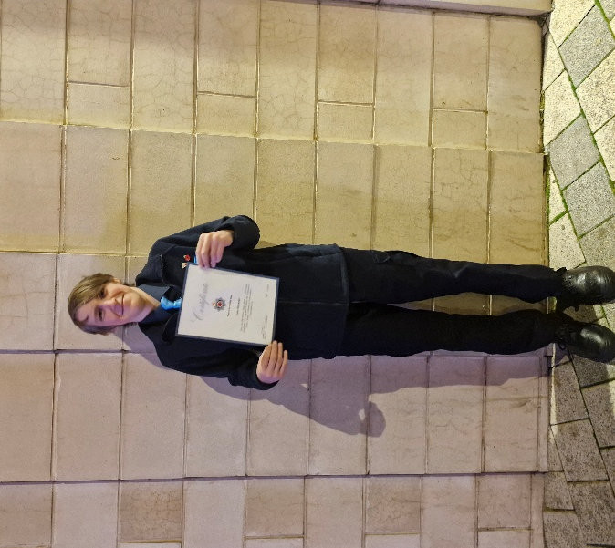
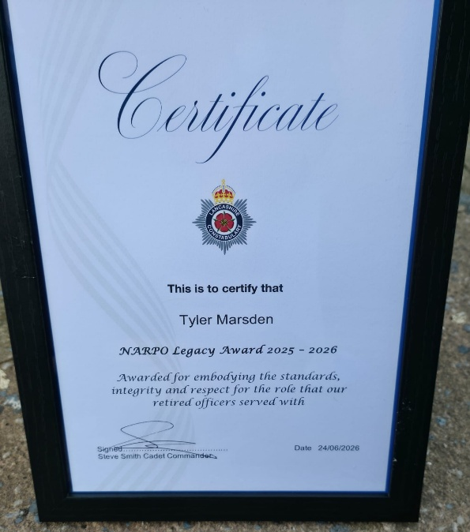
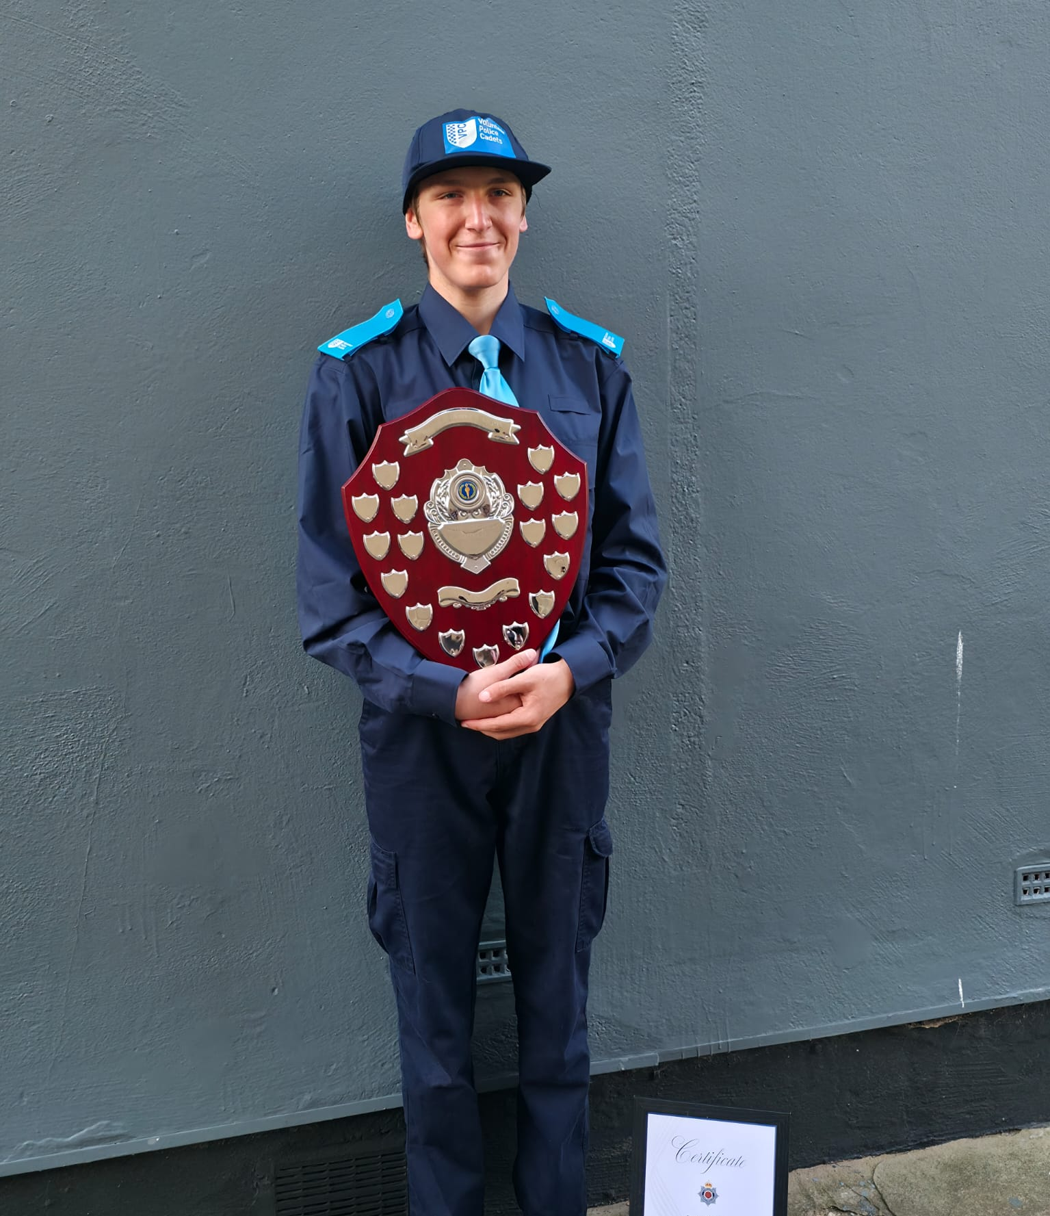
I AM DELIGHTED TO SHARE THAT ONE OF OUR YEAR 11 PUPILS, TYLER MARSDEN, HAS BEEN AWARDED THE LEGACY AWARD BY THE POLICE CADETS THIS WEEK.

TYLER’S MOTHER INFORMED US THAT THIS IS AN EXCEPTIONALLY PRESTIGIOUS ACCOLADE, WHICH IS NOT ORDINARILY PRESENTED TO CADETS. IN FACT, TYLER IS THE FIRST CADET TO EVER RECEIVE THIS AWARD, AS IT HAS TRADITIONALLY BEEN RESERVED FOR RETIRED POLICE OFFICERS IN RECOGNITION OF THEIR OUTSTANDING CONTRIBUTION AND SERVICE.

WE ARE INCREDIBLY PROUD OF TYLER AND THIS REMARKABLE ACHIEVEMENT. HIS DEDICATION, COMMITMENT, AND POSITIVE CONTRIBUTION HAVE BEEN RECOGNISED AT THE HIGHEST LEVEL, AND THIS AWARD IS A TESTAMENT TO THE EXCEPTIONAL YOUNG MAN HE IS.

PUPIL SPECIAL AWARD

