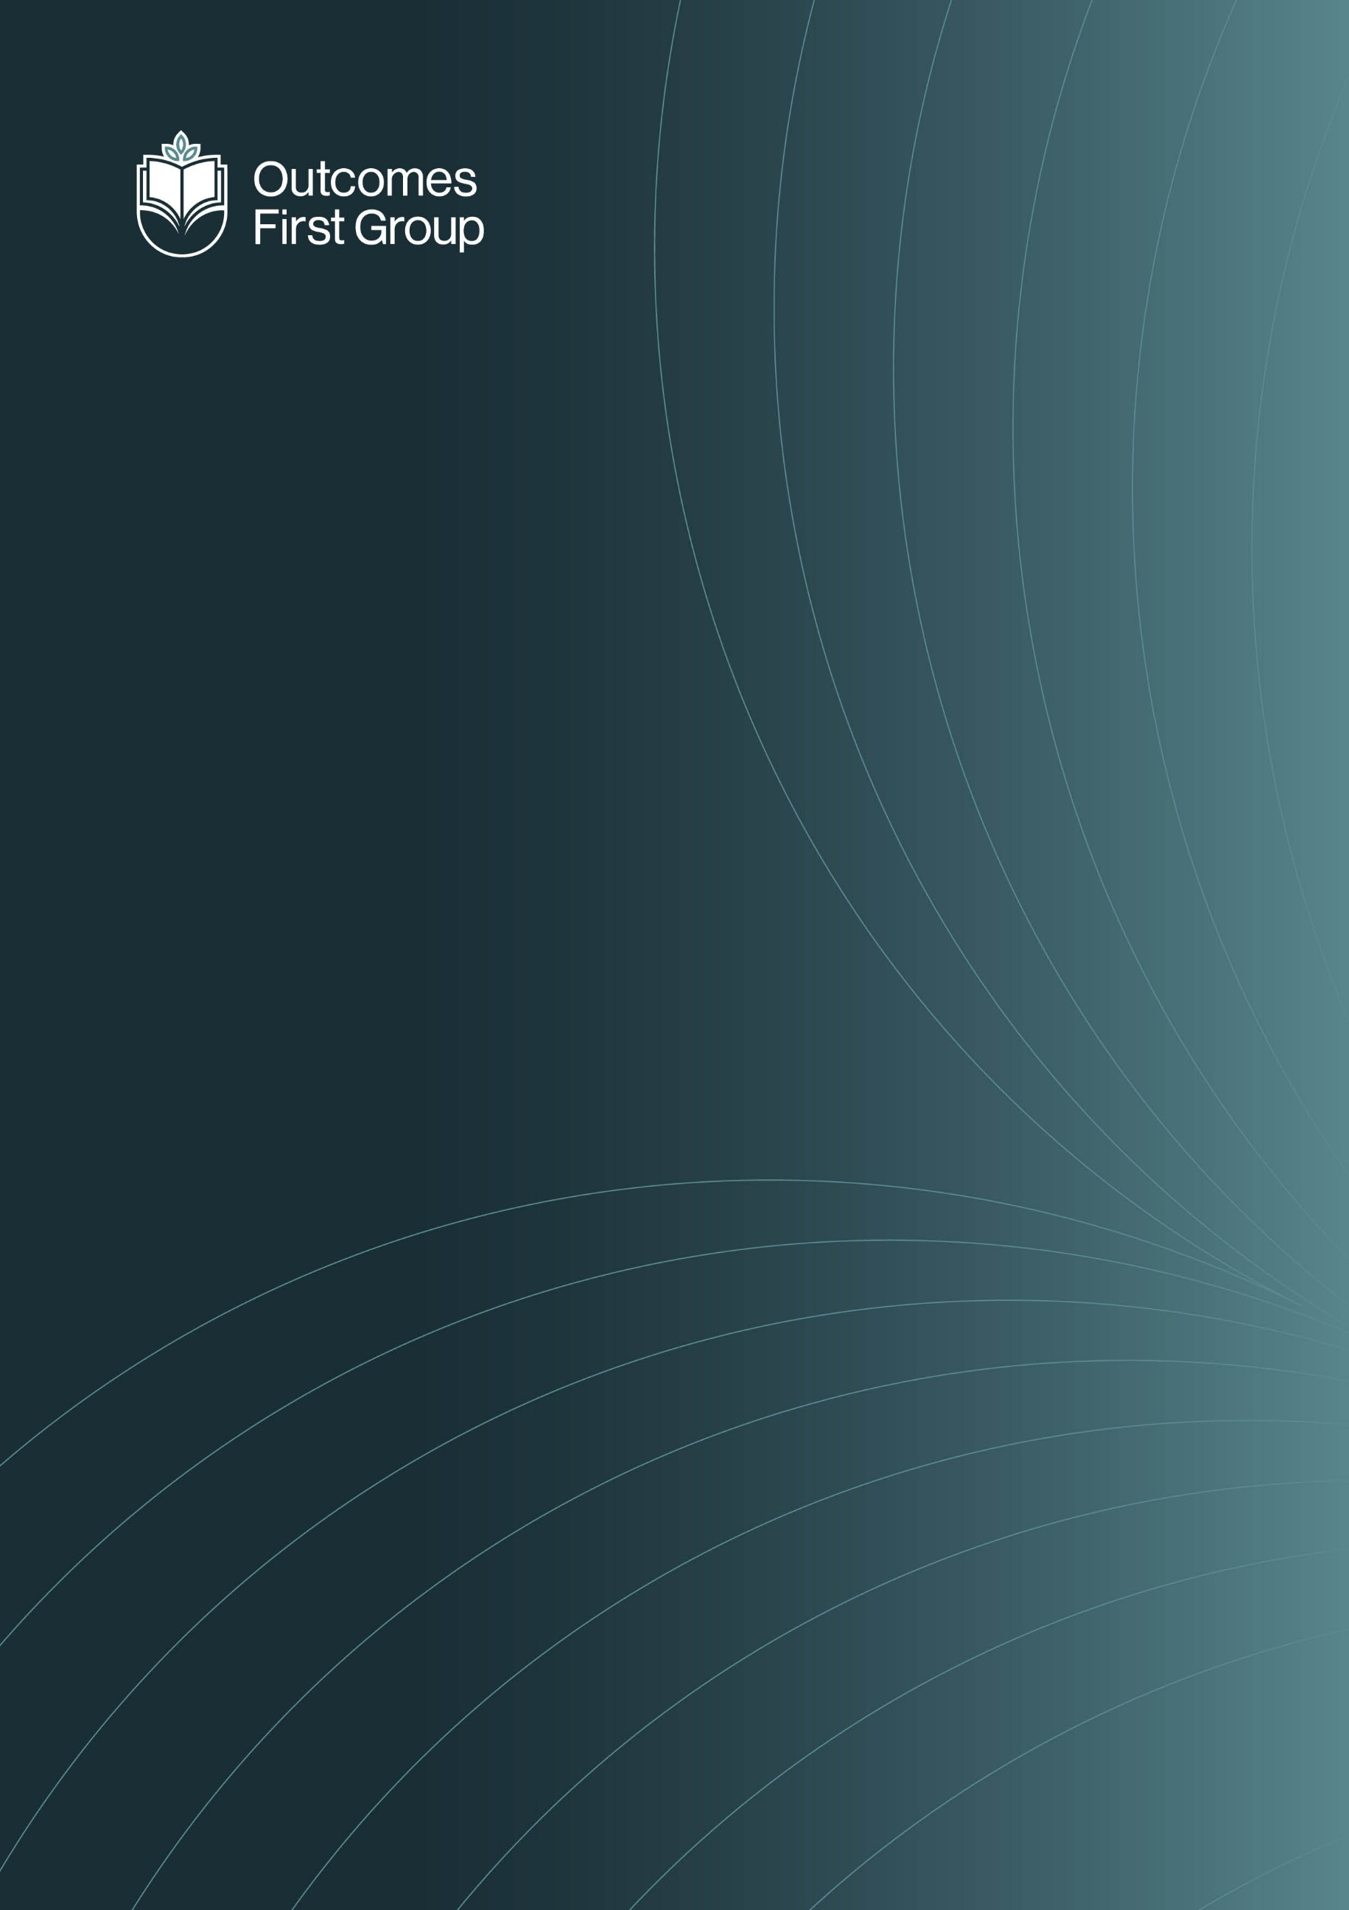

RHSE Policy

RELATIONSHIPS AND SEX EDUCATION POLICY

Contents
1.0 INTRODUCTION AND CONTEXT 1
2.0 STATUTORY REQUIREMENTS 1
3.0 DEFINITION 2
4.0 CURRICULUM DELIVERY 2
5.0 ROLES AND RESPONSIBILITIES 4
6.0 PARENTS RIGHT TO WITHDRAW 4
7.0 POLICY MONITORING AND REVIEW 5
APPENDIX 1 – WHAT IS TAUGHT ACROSS THE KEY STAGES 5
APPENDIX 2 – HOW THE CONTENT IS TAUGHT AT Crookhey Hall School 8

Implementation:

Crookhey Hall School Relationship and Sex Education Policy should be read in conjunction with

- Curriculum Policy
- Safeguarding Policy

Compliance: This policy complies with all relevant regulations and other legislation as detailed in the Compliance with Regulations & Legislation Statement.

INTRODUCTION AND CONTEXT

This Policy is written in accordance with Part 1 – paragraphs 2(2)(d), 2(2)(d)(i), 2(2)(d)(ii) and Part 2, of The Education (Independent School Standards Compliance Record) (England) (Amendment) Regulations (2015).

Crookhey Hall School is an independent day school providing specialist education for children and young people aged 11-16

All of our children have experienced disruption to formal education. For some pupils, this has resulted in long periods of absence which has impacted on their self-esteem and self-confidence. In some cases, pupils have not attended formal education for up to three years.

STATUTORY REQUIREMENTS

In KS3 and 4 We will teach Relationships and Sex education, and Health Education, thus following the statutory guidance as set out by the Department of Education and the Independent School Standards.

In addition at Crookhey Hall School Teaching reflects the law and teaches about applicable laws so that pupils are clear on rights and responsibilities
- Teaching is sensitive, inclusive, and age-appropriate teaching
- Teaching is inclusive to meet the needs of all pupils so that they are able to understand the importance of quality and respect
- Work closely with parents and are respectful of pupils’ and parents’ backgrounds and beliefs
- Communicate the right to request withdrawal from some or all the sex education
- Will consider the age and religious background of all pupils
- Make sure that RSHE is accessible to all pupils, including those with SEND
- Teach about LGBT+ content at integrated and timely point
- Staff team and wider community model positive relationships

Crookhey Hall School complies with the Equality Act 2010:
- We will not treat pupils with protected characteristics (age, sex, race, disability, religion or belief, gender reassignment, pregnancy or maternity, marriage or civil partnership, or sexual orientation less favourably.
- We will make reasonable adjustments and take positive action to alleviate disadvantage, being mindful of the SEND Code of Practice.
- We will regularly review our curriculum content to ensure we are taking positive action towards inclusivity.

DEFINITION

RHSE is about the emotional, social and cultural development of pupils, and involves learning about relationships, sexual health, sexuality, healthy lifestyles, diversity and personal identity.

RHSE involves a combination of sharing information and exploring issues and values.

RHSE is not about the promotion of sexual activity.

CURRICULUM DELIVERY

RHSE is taught within the personal, social, health and economic (PSHE) education curriculum. Biological aspects of RHSE are taught within the science curriculum.

We have developed the curriculum in consultation with parents, pupils and staff, considering the age, complex needs, experiences and trauma of our pupils.
If pupils ask questions outside the scope of this policy and outside of the topics outlined in the PSHE curriculum, teachers will respond in an appropriate manner, so all pupils are fully informed and don’t seek answers online or from other unreliable sources.

Staff will teach pupils the full RHSE curriculum without opinion or imposing their own beliefs and values on pupils. It is the roles of the RHSE teacher and TAs to educate pupils within the curriculum with no bias given, without pupils being told they have negative opinions and with no implementation of how their own values should be formed. The curriculum must be taught in a neutral, informative and fact-based manner always. All viewpoints must be viewed as valid.
Staff at Crookhey Hall School will never impose their political views upon pupils or discuss their views and opinions with pupils at any time.

All staff at Crookhey Hall School who deliver the RHSE curriculum are available to speak to parents, carers and home care staff always to discuss questions and/or concerns relating to the RHSE lessons.

RSHE forms an integral part of our PSHE framework, in addition to the Science Curriculum topics.

We set sex education within a broader base of self-esteem and responsibility for the consequences of one’s actions. We clearly establish what is appropriate and inappropriate in a whole class setting and how to deal with individual questions.

Within RSHE at secondary, we discuss:

1. Respectful relationships, love and care and the responsibilities of parenthood as well as sex
2. building self-esteem;
3. taking on of responsibility and the consequences of one’s actions in relation to sexual activity and parenthood;
4. information about different types of contraception, safe sex and how they can access local sources of further advice and treatment;

Where it is appropriate, we use young people as peer educators to:

1. give students a clear understanding of the arguments for delaying sexual activity and resisting pressure;
2. link sex and relationship education with issues of peer pressure and other risk-taking behaviour, such as drugs, smoking and alcohol.
3. ensure young people understand how the law applies to sexual relationships

Special Educational Needs and/or disabilities

All pupils at Crookhey Hall School have additional learning needs and all have an Education Health Care (EHC) Plan. In order to make sure pupils are able to access the learning in the classroom resources will be differentiated as appropriate to address the learning needs of children in order for them to have full access to the contents of the PSHE and RHSE curriculum.
In most cases, class teachers will be able to determine if any additional support is required for an individual child to access the curriculum. In some cases, the SENCo and parents/carers may wish to work in partnership with the class teacher to tailor the curriculum for individual pupils.

Equality

The DfE Guidance 2019 (p. 15) states, “Schools should ensure that the needs of all pupils are
appropriately met, and that all pupils understand the importance of equality and respect.
Schools must ensure they comply with the relevant provisions of the Equality Act 2010 under
which sexual orientation and gender reassignment are amongst the protected
characteristics…”

LGBT content is integrated fully into our curriculum. It is not specifically taught as stand-alone lessons within units. All pupils will be taught LGBT+ content in an age-appropriate manner at a timely point in the curriculum.
At Crookhey Hall School we promote respect for all and value every individual child. However, we also respect the rights of our children, families and our staff to hold beliefs, religious or otherwise.

Should any content within our curriculum cause parents or carers any concern then we would invite them in to discuss these concerns with the school.
For information on what it taught, how it is taught and when it is taught, please refer to Appendix 1.

ROLES AND RESPONSIBILITIES

The Headteacher
The Headteacher is responsible for ensuring that RHSE is taught consistently across the school, and for managing requests to withdraw pupils from the non-statutory components of RHSE.

Staff
Staff are responsible for:
o Delivering RHSE in a sensitive way
o Modelling positive attitudes to RHSE
o Monitoring progress
o Responding to the needs of individual pupils
o Responding appropriately to pupils whose parents wish them to be withdrawn from the non-statutory components of RHSE

Staff do not have the right to opt out of teaching RHSE. Staff who have concerns about teaching RHSE are encouraged to discuss this with the Headteacher.

Pupils
Pupils are expected to engage fully in RHSE and, when discussing issues related to RHSE, treat others with respect and sensitivity.

PARENTS RIGHT TO WITHDRAW

“Parents have the right to request that their child be withdrawn from some or all
sex education delivered as part of statutory Relationships, Health and Sex Education” DfE
Guidance p.17

All staff at Crookhey Hall School strongly believe that all children should have access to our sex education programme as outlined above.
If a parent/carer wishes to withdraw their child from components of Sex Education lessons, then they must inform the school in writing a week prior to the lesson taking place in order that alternative arrangements can be made for the child’s education.

Parents do not have the right to withdraw their children from relationships education.
Parents have the right to withdraw their children from the non-statutory components of sex education within RHSE, up to and until 3 terms before the child turns 16. After this point, if the child wishes to receive sex education rather than being withdrawn, the school will arrange this.

Requests for withdrawal should be put in writing and addressed to the Headteacher and Designated Safeguarding Lead.
Alternative work will be given to pupils who are withdrawn from relationships, health and sex education lessons.

There are separate rules on withdrawing a child from RHSE. Sex education is separate from the Relationships and Health curriculum and parents can withdraw children from some or all of the lessons on Sex Education. The Headteacher must grant a parent’s request to withdraw a child beforehand, and it’s useful to have good conversations with parents so that they understand fully what their child will be taught. A copy of withdrawal requests will be placed in the pupil’s educational record.

Before making a request, parents should:

Ask the school about what will be taught in Sex Education lessons and how these lessons will be delivered to pupils who have traumatic experiences, are SEND pupils and may have many individual and personal barriers to learning about sex education.
The science curriculum in all schools includes content on human development, which includes human reproduction. Remember there is no right for a parent to withdraw their child from the science curriculum.

All staff at Crookhey Hall School are qualified SEND/SEMH practitioners who are experienced in delivering lessons to pupils who have multiple, complex needs and who have experienced trauma at different stages in their lives. Pupils are taught in small groups with TA support and lessons within sex education will be adapted to suit individual pupils’ needs and capabilities.
The teachers delivering RHSE are available to speak with parents, carers and care home staff at any time regarding questions or concerns within the RHSE curriculum.

POLICY MONITORING AND REVIEW

The senior leadership team monitor this policy on an annual basis.

APPENDIX 1 – WHAT IS TAUGHT ACROSS THE KEY STAGES

By the end of KS3 and KS4

Families
RE 1 • that there are different types of committed, stable relationships.
RE 2 • how these relationships might contribute to human happiness and their importance for bringing up children.
RE 3 • what marriage is, including their legal status e.g. that marriage carries legal rights and protections not available to couples who are cohabiting or who have married, for example, in an unregistered religious ceremony.
RE 4 • why marriage is an important relationship choice for many couples and why it must be freely entered into.
RE 5 • the characteristics and legal status of other types of long-term relationships.
RE 6 • the roles and responsibilities of parents with respect to raising of children, including the characteristics of successful parenting.
RE 7 • how to: determine whether other children, adults or sources of information are trustworthy: judge when a family, friend, intimate or other relationship is unsafe (and to recognise this in others’ relationships); and, how to seek help or advice, including reporting concerns about others, if needed.

Respectful relationships, including friendships
RE 8 • the characteristics of positive and healthy friendships (in all contexts, including online) including: trust, respect, honesty, kindness, generosity, boundaries, privacy, consent and the management of conflict, reconciliation and ending relationships. This includes different (non-sexual) types of relationship.
RE 9 • practical steps they can take in a range of different contexts to improve or support respectful relationships.
RE 10 • how stereotypes, in particular stereotypes based on sex, gender, race, religion, sexual orientation or disability, can cause damage (e.g. how they might normalise non-consensual behaviour or encourage prejudice).
RE 11 • that in school and in wider society they can expect to be treated with respect by others, and that in turn they should show due respect to others, including people in positions of authority and due tolerance of other people’s beliefs.
RE 12 • about different types of bullying (including cyberbullying), the impact of bullying, responsibilities of bystanders to report bullying and how and where to get help.
RE13 • that some types of behaviour within relationships are criminal, including violent behaviour and coercive control.
RE 14 • what constitutes sexual harassment and sexual violence and why these are always unacceptable.
15 • the legal rights and responsibilities regarding equality (particularly with reference to the protected characteristics as defined in the Equality Act 2010) and that everyone is unique and equal.

Online and media
RE 16 • their rights, responsibilities and opportunities online, including that the same expectations of behaviour apply in all contexts, including online.
RE 17 • about online risks, including that any material someone provides to another has the potential to be shared online and the difficulty of removing potentially compromising material placed online.
RE 18 • not to provide material to others that they would not want shared further and not to share personal material which is sent to them.
RE 19 • what to do and where to get support to report material or manage issues online.
RE 20 • the impact of viewing harmful content.
RE 21 • that specifically sexually explicit material e.g. pornography presents a distorted picture of sexual behaviours, can damage the way people see themselves in relation to others and negatively affect how they behave towards sexual partners.
RE 22 • that sharing and viewing indecent images of children (including those created by children) is a criminal offence which carries severe penalties including jail.
RE 23 • how information and data is generated, collected, shared and used online.

Being safe
RE 24 • the concepts of, and laws relating to, sexual consent, sexual exploitation, abuse, grooming, coercion, harassment, rape, domestic abuse, forced marriage, honour-based violence and FGM, and how these can affect current and future relationships.
RE 25 • how people can actively communicate and recognise consent from others, including sexual consent, and how and when consent can be withdrawn (in all contexts, including online).

Intimate and sexual relationships, including sexual health
RE 26 • how to recognise the characteristics and positive aspects of healthy one-to-one intimate relationships, which include mutual respect, consent, loyalty, trust, shared interests and outlook, sex and friendship.
RE 27 • that all aspects of health can be affected by choices they make in sex and relationships, positively or negatively, e.g. physical, emotional, mental, sexual and reproductive health and wellbeing.
RE 28 • the facts about reproductive health, including fertility, and the potential impact of lifestyle on fertility for men and women and menopause.
RE 29 • that there are a range of strategies for identifying and managing sexual pressure, including understanding peer pressure, resisting pressure and not pressurising others.
RE 30 • that they have a choice to delay sex or to enjoy intimacy without sex.
RE 31 • the facts about the full range of contraceptive choices, efficacy and options available.
RE 32 • the facts around pregnancy including miscarriage.
RE 33 • that there are choices in relation to pregnancy (with medically and legally accurate, impartial information on all options, including keeping the baby, adoption, abortion and where to get further help).
RE 34 • how the different sexually transmitted infections (STIs), including HIV/AIDs, are transmitted, how risk can be reduced through safer sex (including through condom use) and the importance of and facts about testing.
RE 35 • about the prevalence of some STIs, the impact they can have on those who contract them and key facts about treatment.
RE 36 • how the use of alcohol and drugs can lead to risky sexual behaviour.
RE 37 • how to get further advice, including how and where to access confidential sexual and reproductive health advice and treatment

Physical health and mental wellbeing:
By the end of Secondary School, pupils should know:

Mental wellbeing
PM 1• how to talk about their emotions accurately and sensitively, using appropriate vocabulary.
PM 2 • that happiness is linked to being connected to others.
PM 3 • how to recognise the early signs of mental wellbeing concerns.
PM 4 • common types of mental ill health (e.g. anxiety and depression).
PM 5 • how to critically evaluate when something they do or are involved in has a positive or negative effect on their own or others’ mental health.
PM 6 • the benefits and importance of physical exercise, time outdoors, community participation and voluntary and service-based activities on mental wellbeing and happiness.

Internet safety and harms
PM 7 • the similarities and differences between the online world and the physical world, including: the impact of unhealthy or obsessive comparison with others online (including through setting unrealistic expectations for body image), how people may curate a specific image of their life online, over-reliance on online relationships including social media, the risks related to online gambling including the accumulation of debt, how advertising and information is targeted at them and how to be a discerning consumer of information online.
PM 8 • how to identify harmful behaviours online (including bullying, abuse or harassment) and how to report, or find support, if they have been affected by those behaviours.

Physical health and fitness
PM 9 • the positive associations between physical activity and promotion of mental wellbeing, including as an approach to combat stress.
PM 10 • the characteristics and evidence of what constitutes a healthy lifestyle, maintaining a healthy weight, including the links between an inactive lifestyle and ill health, including cancer and cardiovascular ill-health.
PM 11 • about the science relating to blood, organ and stem cell donation.

Healthy eating
PM 12 • how to maintain healthy eating and the links between a poor diet and health risks, including tooth decay and cancer.
Drugs, alcohol and tobacco
PM 13 • the facts about legal and illegal drugs and their associated risks, including the link between drug use, and the associated risks, including the link to serious mental health conditions.
PM 14 • the law relating to the supply and possession of illegal substances.
PM 15 • the physical and psychological risks associated with alcohol consumption and what constitutes low risk alcohol consumption in adulthood.
PM 16 • the physical and psychological consequences of addiction, including alcohol dependency.
PM 17 • awareness of the dangers of drugs which are prescribed but still present serious health risks.
PM 18 • the facts about the harms from smoking tobacco (particularly the link to lung cancer), the benefits of quitting and how to access support to do so.

Health and prevention
PM 19 • about personal hygiene, germs including bacteria, viruses, how they are spread, treatment and prevention of infection, and about antibiotics.
PM 20 • about dental health and the benefits of good oral hygiene and dental flossing, including healthy eating and regular check-ups at the dentist.
PM 21 • (late secondary) the benefits of regular self-examination and screening.
PM 22 • the facts and science relating to immunisation and vaccination.
PM 23 • the importance of sufficient good quality sleep for good health and how a lack of sleep can affect weight, mood and ability to learn.

Basic first aid
PM 24 • basic treatment for common injuries.
PM 25 • life-saving skills, including how to administer CPR.
PM 26 • the purpose of defibrillators and when one might be needed.

Changing adolescent body
PM 27 • key facts about puberty, the changing adolescent body and menstrual wellbeing.
PM 28 • the main changes which take place in males and females, and the implications for emotional and physical health.

APPENDIX 2 – HOW THE CONTENT IS TAUGHT AT Crookhey Hall School

At Crookhey Hall School the RHSE curriculum is:

- Appropriate for children’s ages and development stage
- Sensitive to the needs and religious backgrounds of the children in the school
- Delivered discretely as part of our comprehensive PSHE curriculum
- Taught in small group settings or one to one if appropriate
- Through additional targeted workshops if a need is identified
- Responsive to the needs and context of the school, if trends, patterns and misconceptions are identified, the content is adapted, and sessions may be brought forward if a need rises within a group or from an individual

