
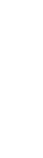
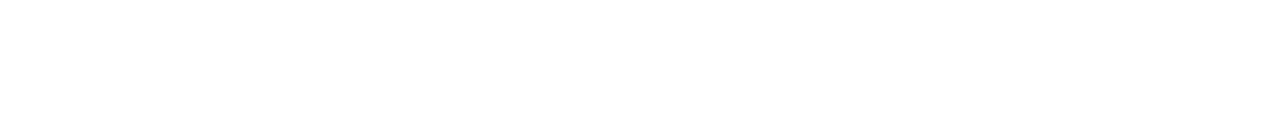
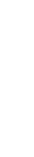
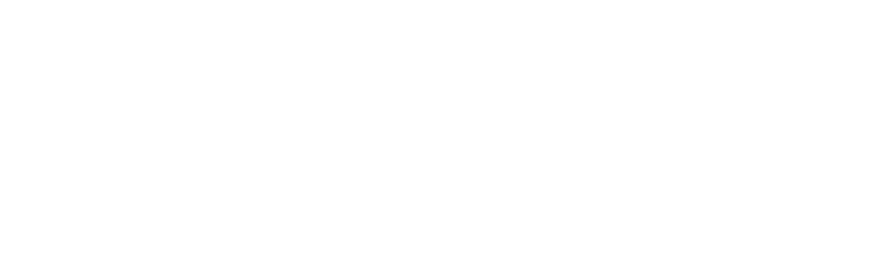

Admissions

P
olicy

Crookhey Hall School

The aims of this policy is:-
- To ensure that the school admits, as far as is possible, those pupils whose special educational needs can be met effectively and in doing so ensure progress in all aspects of their development.
- To establish clear and rigorous procedures for the admission of pupils into Crookhey Hall School

Rationale:-
The School will be admitting pupils with social emotional and mental health difficulties, frequently but not always, accompanied with a diagnosis of autism and/or other neurodiversity. All pupils arrive with an with an Education, Health, and Care Plan (EHCP), which notes the nature of these difficulties, or an education health and care plan, may be in the process of being written. Such difficulties are often the cause or the result of other special educational needs. They may arrive out of difficult life experiences or be the result of a medical condition. Therefore, the school acknowledges that our pupils may, from time to time, exhibit challenging behaviours that vary both in intensity and duration. The range and nature of both the difficulties and needs our pupils exhibit, have and continue to become more complex as does the assessment of these. Thus, it is important that the school seeks to ensure that the admission process accurately identifies the needs of pupils and whether it is possible for the school to meet these both effectively and efficiently.

The objectives of the policy are that: -
All concerned will have a clear understanding of the criteria used in assessing the appropriateness of a placement for individual pupils at The School.
All concerned will have a clear understanding of the processes of judging the appropriateness of that placement.
Parents/carers, each pupil and representatives of Local Authorities, social service departments, and other interested professionals have clear understanding of the opportunities on offer at the school.

Procedure for Admissions:-

- Applications for admission to Crookhey Hall School are normally made by a SEN Officer of the Local Authority in whose area the pupil currently resides. The officer will contact the school direct or via their Admission manager and send over the relevant documents relating to the pupil.

- Regulations under the Education Act 2011 and all subsequent legislation state that parents have the right to express a preference for a school which is not a LA school, but which is an Independent special school approved by the DFE. If the LA agrees it will fund the placement at that school.

- All of the pupils referred to Crookhey Hall School will have a history of SEMH and or associated learning difficulties. Pupils will be aged between 10 to 17 years, and be in Key Stage 2, Key Stage 3, or Key Stage 4 (academic Year 5 to Year 12.)

- The initial visit will take place either during the school day or after school. This allows all pupils, parents, carers, social workers etc. or anybody else who has accompanied the pupil to have:
a tour of the school, an introduction to key staff, a discussion with senior staff concerning such issues as: the school curriculum, the prospective pupil’s likes and dislikes. The content of key school policies, including the school expectations for good behaviour and discipline and the physical management of pupils. A discussion about the school’s physical intervention strategy. And an opportunity for each visitor to ask any questions they may have

- If, following these visits, all concerned are agreed that the pupil’s needs as outlined in the EHCP or other documentation can be met at the school, and that the young person can be adequately managed with the planned resources available, and that the pupil and parents/carers are committed to the placement, the school will formally offer a place in writing through our admissions manager

7. Referrals Procedure
Pupils are referred to Crookhey Hall School from a wide variety of Local Authorities based in the North-West of England. The referral will be sent to the schools admission manager at OFG. The referral will be logged on to our management system and the Head Teacher and SENCo will review papers and decide whether need can be met. The pupil and parents/carers will be invited in for a meeting during this process.

8. Admission Criteria:-

- The pupil will be aged between 10 and 17 years
- The pupil will have an Education, Health and Care Plan
- The plan will specify that the pupil has social, emotional and mental health difficulties
(SEMH), autism (ASD), or social communication difficulties as a primary need
- The pupil will normally have been assessed as within the average ability range of educational functioning. (In some cases, pupil’s levels of ability as measured using psychometric tests may prove difficult. In these cases, the school will base its judgements on its ability to meet needs) - The pupil may have learning difficulties and/or low attainment that are associated with their emotional and behavioural difficulties, but these can be supported within the normal education offer. The pupil may have one or more specific learning difficulties, such as dyslexia
- The pupil will express a commitment to the placement
- The pupil’s parents/carers will express a commitment to the placement.
- For all Children Looked After (CLA) there must be permanently named carers and a permanent home base for the pupil, available at any time throughout the year. This placement should be stable and secure.
- The admittance of the pupil will not be detrimental to other pupils already on the school role - There is a space available in the pupil’s academic year group so their curriculum need can be met

- Pupils are admitted at any time in the school year although it is easier for pupils to start at the beginning of a term or half term. We endeavour to start all pupils on a Monday.

- Once a decision has been reached; and funding has been agreed by the Local Authority, a start date will be agreed, and transport will also be arranged where appropriate.

11. Transitional Start:-
- Unless it is not convenient with a parent or carer who may be working or have other commitments, all pupils will start Crookhey Hall School on a transition basis to be agreed with all stakeholders
- All cases are considered on an individual basis and it may require a longer transition period for pupils who have been out of school for long periods or who are suffering from high anxiety, this will be arranged.
- A risk assessment and educational assessment will be completed during the first half-term.

12. If pupils are admitted from other educational establishments within the school year careful individual transition arrangements will be made with the young person's previous school. Similarly, if a young person transfers from Crookhey Hall to elsewhere.

All parents will be given an Admissions pack, which contains the following information to be read or to be completed by parents prior to their child’s start date.

- General consent form
- Child friendly GDPR privacy notice
- 1 Page pupil profile/Getting To Know You Form
- Child friendly anti bullying policy
- Photograph consent form
- Privacy notice
- Pupil Information form
- School day timings
- Medical form
- Relevant persons contact details
- Code of Conduct
- Worried or Complaints leaflet
- Therapy consent form

13. Discharge Process
In the unfortunate situation that the school is unable to continue to meet need for a pupil, and all avenues have been explored, the school will work with the Local Authority and serve a 6 week notice letter for that pupil.

Policy Number | VERSION 01
Date of last review | April 2026
Date of next review | September 2026
Reviewed by | Michael Savage

