
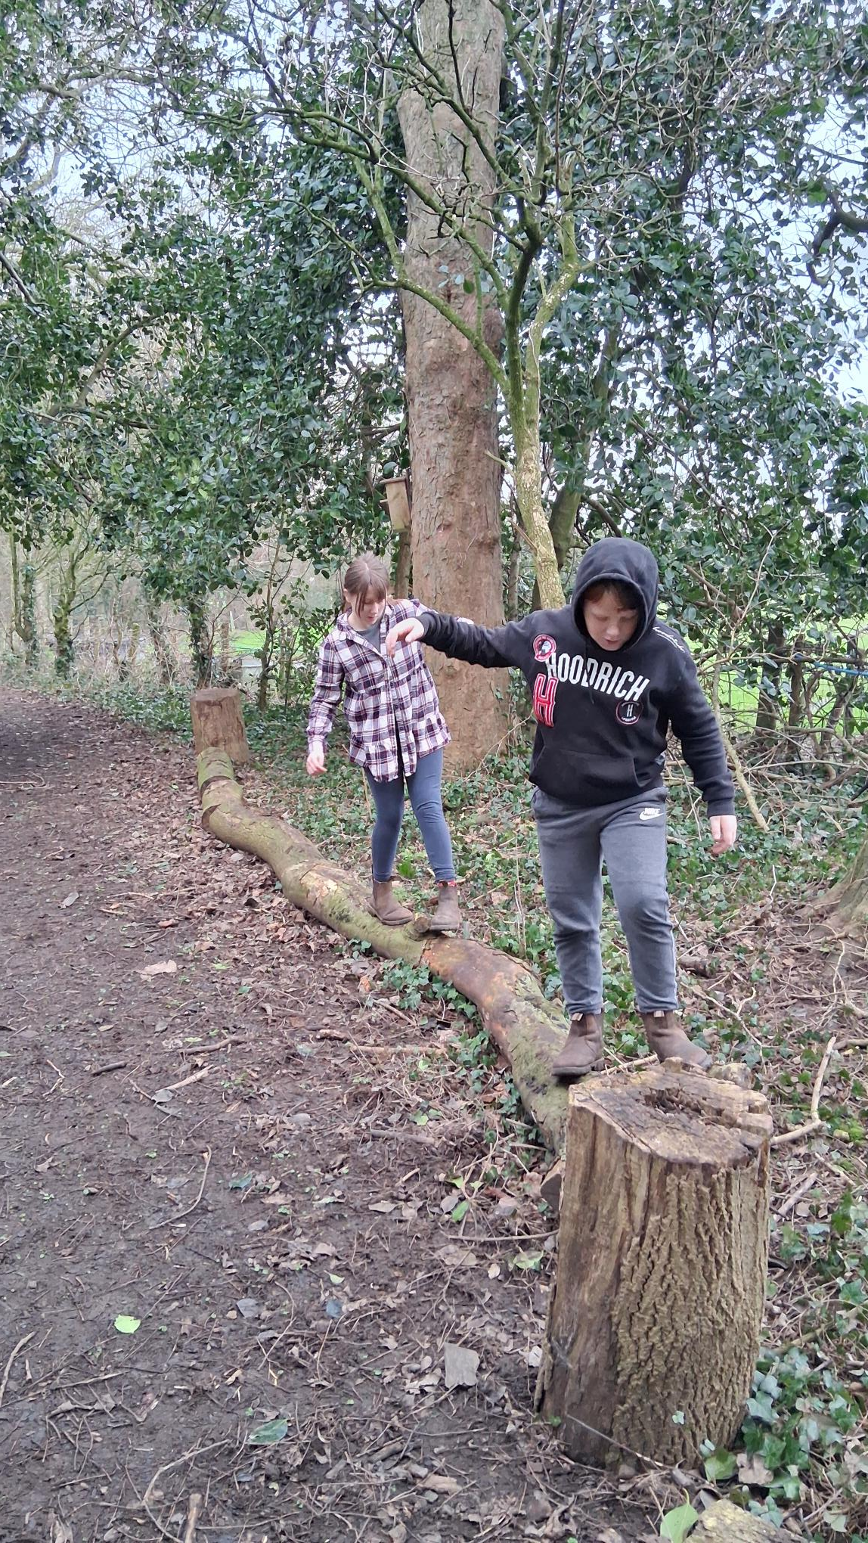
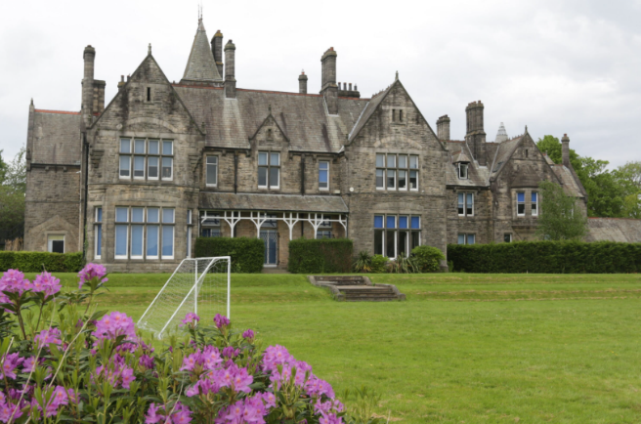





BELIEVE ☆ INSPIRE ☆ ACHIEVE
SPRING TERM
2026
SEE HOW CLASSES 10, 12 AND 13 EXPLORED CAREERS IN THE POLICE FORCE AND BECAME INVESTIGATORS FOR THE DAY!

JOIN US IN OUR SWEET SCIENCE LESSONS AS WE LEARN ABOUT THE STRUCTURE OF DNA

SEE HOW LOWER SCHOOL CELEBRATED INTERNATIONAL WOMEN’S DAY WITH THEIR HOMAGES TO INSPIRATIONAL WOMEN THROUGHOUT HISTORY

OUR SPRING TERM HAS BEEN PACKED WITH INTERESTING VISITORS, AMAZING EVENTS, AND LOTS OF INTERACTIVE LEARNING BOTH ON- AND OFF-SITE. OUR SUBJECT SPOTLIGHT THIS TERM IS CATERING – SEE OUR DEEP-DIVE ON PAGE 3

CROOKHEY HALL SCHOOL
It has been a busy Spring Term here at Crookhey Hall School —filled with curiosity, creativity, and incredible achievement .
This term, our students have explored an impressive range of hands-on experiences, from delving into the world of forensic investigation with our police careers workshop, to constructing colourful DNA models in science, to developing real-world skills through catering, hair and beauty, outdoor education, and post-16 college sessions. Their engagement has been fantastic , and we are proud of the confidence and independence they continue to build. We have also celebrated important events together, including the thoughtful and creative tributes produced for International Women’s Day. Our SMSC, curriculum, and intervention sessions have provided rich opportunities for pupils to grow academically, socially, and emotionally — whether through vibrant maths activities, microscope investigations, forest school fire safety, or expressive fine motor work.
The breadth of learning both in and beyond the classroom has been wonderful, supported by dedicated staff and inspiring visitors who help bring subjects to life. This reflects our commitment to helping pupils believe, inspire, and achieve.
This term we have welcomed new staff members, Ruth Mc Ewan, Jakob Shaw, Yvette Allen and Chloe Townley, Our new students have settled in well enjoying everything Crookhey has to offer
I hope you enjoy reading about the many highlights from this busy term. We are incredibly proud of our pupils and everything they continue to accomplish.
Thank you for your support this term and I hope you have a wonderful Easter Break. Jane Husbands

A MESSAGE FROM THE HEAD
PAGE 3: SUBJECT SPOTLIGHT
PAGE 4: SMSC EVENTS
PAGES 5&6: CURRICULUM NEWS
PAGE 7: INTERVENTIONS
PAGE 8: VISTORS

IN THIS TERM’S
NEWSLETTER:
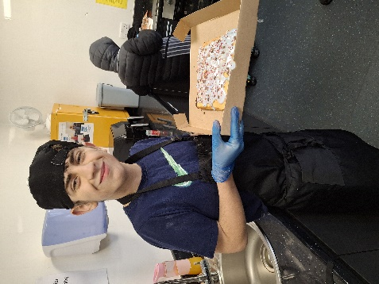
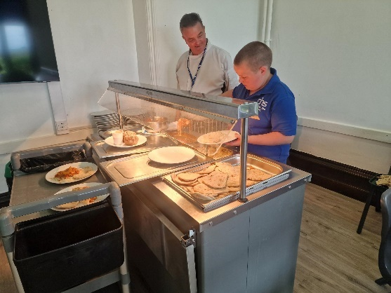
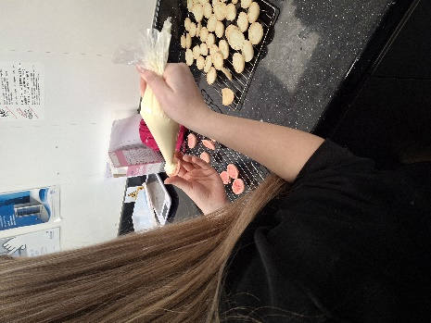
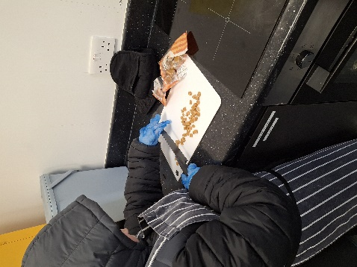
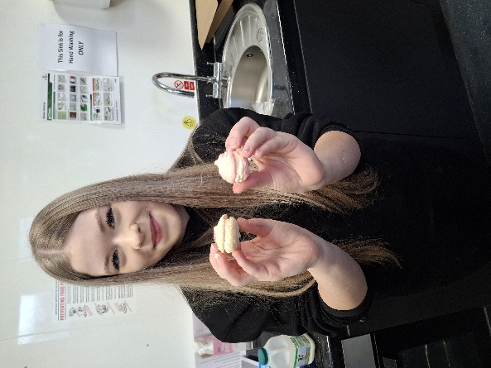
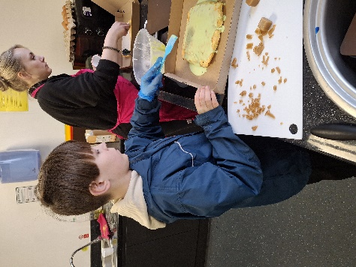
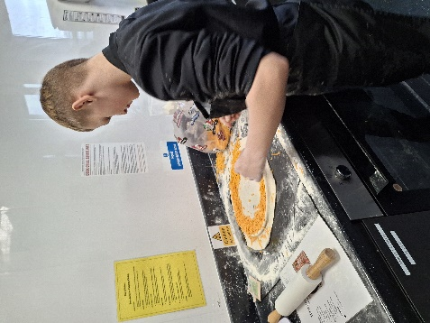
SUBJECT SPOTLIGHT
IN CATERING, PUPILS LEARN HOW TO:
- PREPARE SIMPLE, NUTRITIOUS MEALS
- FOLLOW RECIPES AND INSTRUCTIONS
- USE KITCHEN EQUIPMENT SAFELY
- WORK AS PART OF A TEAM
- BUILD CONFIDENCE AND RESPONSIBILITY

THE KITCHEN OFFERS A SENSORY-RICH LEARNING SPACE WHERE PUPILS CAN EXPLORE TASTES, TEXTURES, AND SMELLS IN A CONTROLLED AND SUPPORTIVE WAY. THIS HELPS TO DEVELOP COMMUNICATION, EMOTIONAL REGULATION, AND CONFIDENCE.

WE ARE INCREDIBLY PROUD OF THE EFFORT, RESILIENCE, AND CREATIVITY OUR PUPILS SHOW IN THE KITCHEN – FROM BAKING SWEET TREATS TO PREPARING SAVOURY DISHES, EVERY SESSION IS A CHANCE TO LEARN, GROW, AND SUCCEED.
MANY PUPILS WHO STRUGGLE IN TRADITIONAL CLASSROOM SETTINGS THRIVE IN OUR CATERING LESSONS. THE PRACTICAL NATURE OF THE SUBJECT ALLOWS THEM TO EXPERIENCE SUCCESS, BUILD SELF-ESTEEM, AND DEVELOP POSITIVE RELATIONSHIPS WITH STAFF AND PEERS.
AT CROOKHEY HALL, CATERING IS ABOUT FAR MORE THAN JUST COOKING – IT’S ABOUT BUILDING CONFIDENCE, INDEPENDENCE, AND REAL-WORLD SKILLS IN A SUPPORTIVE, HANDS-ON ENVIRONMENT.

CATERING

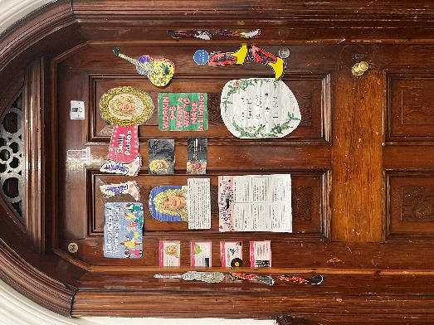
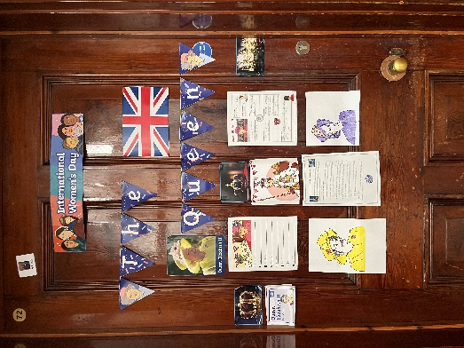
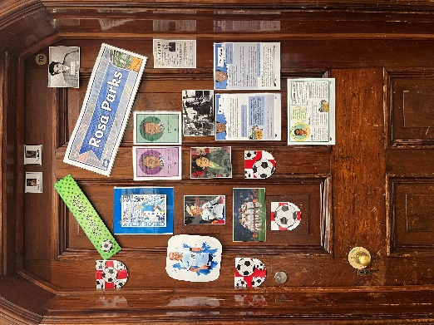
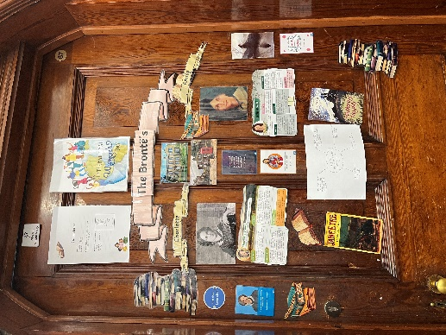
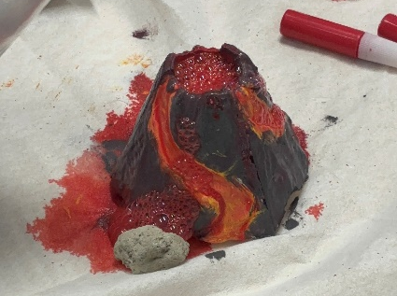
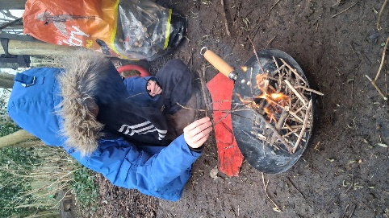
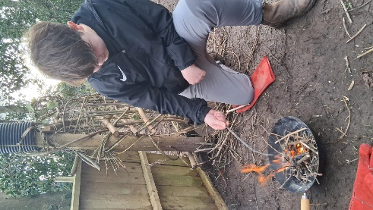
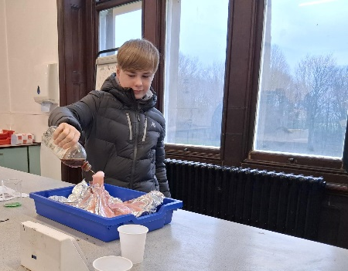
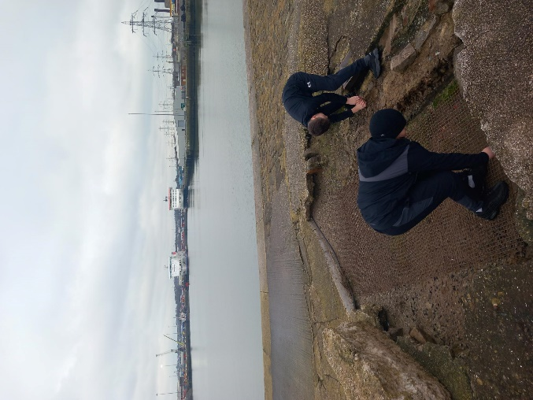
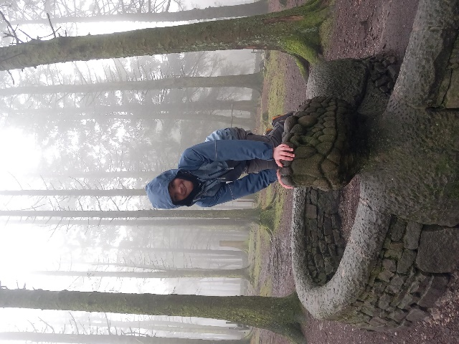
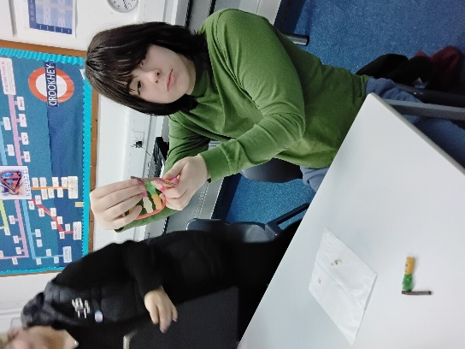
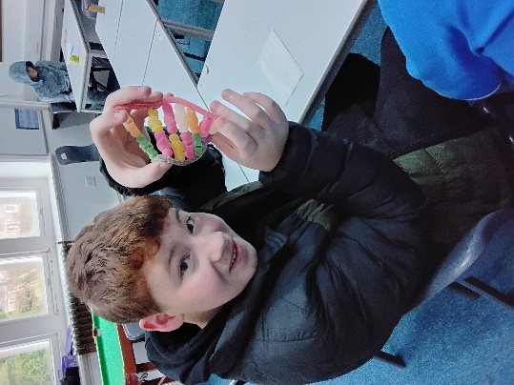
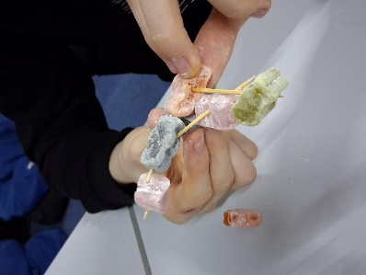
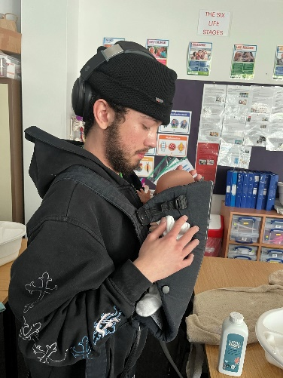
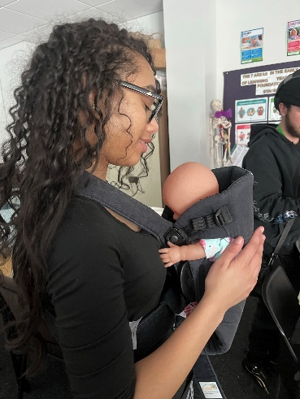
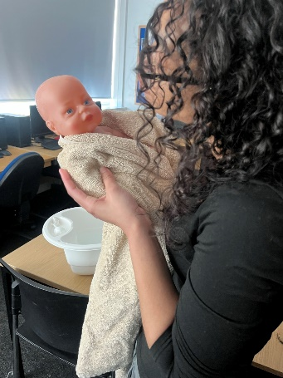
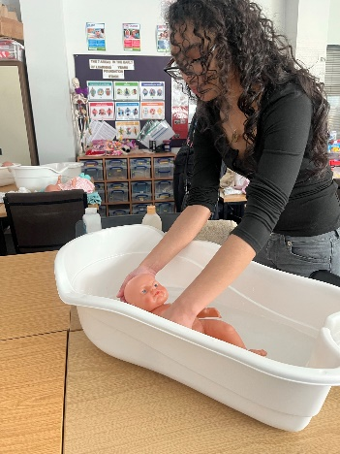
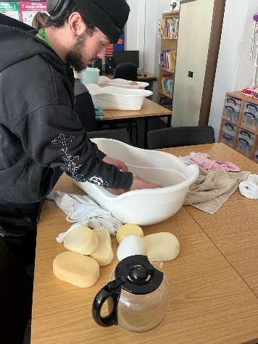
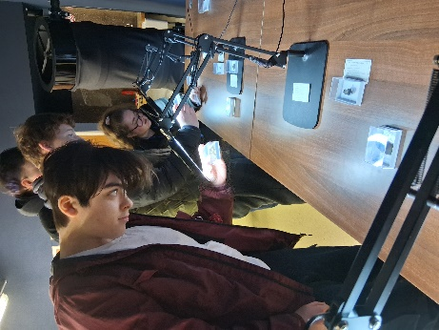
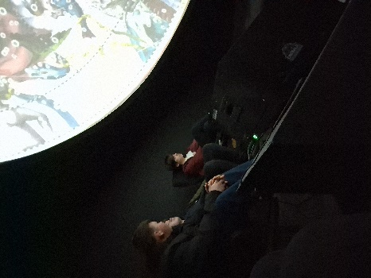
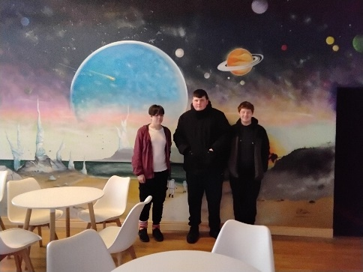
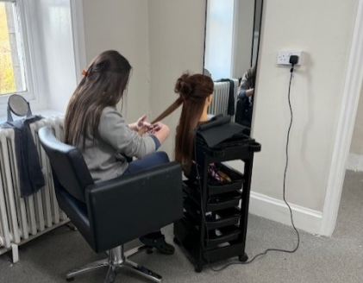
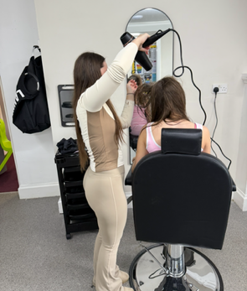
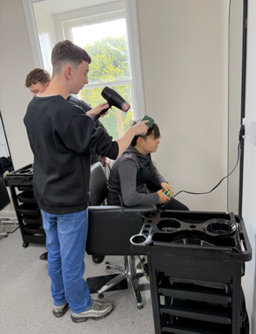
CLASS 12
CLASS 10
CLASS 11
CLASS 13
DURING THE WEEK BEFORE THE 8TH MARCH, EACH CLASS PICKED AN INSPIRATIONAL WOMAN OR WOMEN FROM HISTORY, LITERATURE, SPORT, MUSIC OR FILM TO CREATE A HOMAGE BY DECORATING THEIR CLASSROOM DOORS. DURING FORM TIME, WE DISCUSSED AND RESEARCHED THE IMPORTANT IMPACT THESE WOMEN HAD ON THE WORLD.

INTERNATIONAL WOMEN’S DAY
SMSC EVENTS
DURING OUR FOREST SCHOOL SESSIONS, PUPILS LEARNED ABOUT FIRE SAFETY AND THE IMPORTANT USES OF FIRE IN THE OUTDOORS. WE DISCUSSED HOW TO BUILD AND MANAGE A FIRE RESPONSIBLY, INCLUDING THE NEED FOR A CLEAR FIRE CIRCLE, KEEPING A SAFE DISTANCE, AND ALWAYS HAVING AN ADULT SUPERVISING.

IN HUMANITIES THIS TERM, WE HAVE BEEN LEARNING ABOUT VOLCANOES WITH HELP FROM THE SCIENCE DEPARTMENT. USING SCIENCE, WE DEMONSTRATED HOW AND WHY VOLCANOES ERUPT.

IN OUTDOOR EDUCATION THIS TERM, WE HAVE BEGUN TO LEARN ABOUT ORIENTEERING, USING MAPS TO NAVIGATE OUR WAY THROUGH NATURE RAMBLES AND FIND HIDDEN SURPRISES. WE HAVE ALSO RESEARCHED OUR TIDE TIMES AND WORKED SAFELY TO FIND SEASIDE WILDLIFE.

IN SCIENCE THIS TERM, STUDENTS EXPLORED THE FASCINATING STRUCTURE OF DNA IN A FUN AND HANDS-ON WAY BY BUILDING THEIR OWN DNA STRANDS USING SWEETS. THIS CREATIVE ACTIVITY SUPPORTED STUDENTS IN UNDERSTANDING HOW GENETIC INFORMATION IS STORED AND ORGANISED IN LIVING THINGS, WHILE ALSO ENCOURAGING TEAMWORK, PROBLEM-SOLVING, AND PLENTY OF EXCITEMENT. IT WAS A LESSON THAT COMBINED SCIENCE, CREATIVITY, AND A LITTLE BIT OF SWEETNESS TO BRING LEARNING TO LIFE.

CURRICULUM
THIS TERM, OUR POST-16 STUDENTS HAVE BEEN ATTENDING LANCASTER AND MORECAMBE COLLEGE TO TAKE PART IN A CHILDCARE UNIT FROM THEIR HEALTH AND SOCIAL CARE COURSE, LEARNING HOW TO PROPERLY CARE FOR BABIES.

DURING LIFE SKILLS, WE HAVE BEEN VISITING LOCAL LANDMARKS AND AREAS OF INTEREST, INCLUDING CLASS 6’S TRIP TO GRIZEDALE OBSERVATORY.

IN OUR HAIR, BEAUTY AND BARBERING COURSE THIS TERM, WE LEARNED HOW TO WASH AND BLOW-DRY HAIR, AND OUR YEAR 11s MOVED ON AND USED THE MANNEQUIN HEADS TO LEARN HOW TO DO A STRAIGHT CUT.

CURRICULUM

INTERVENTIONS

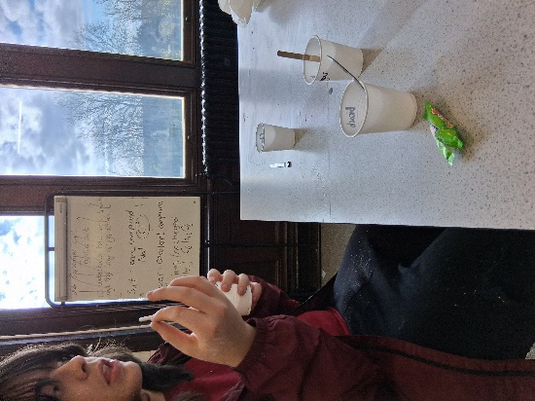
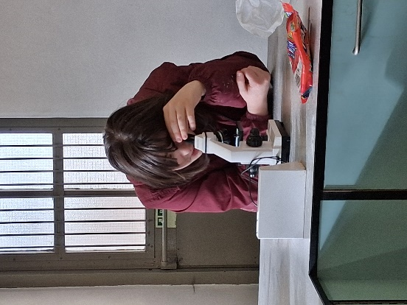
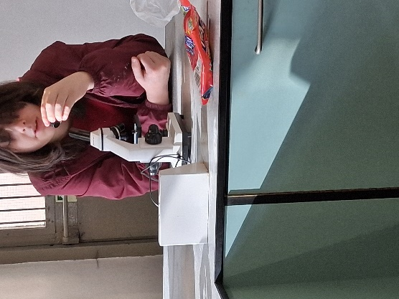
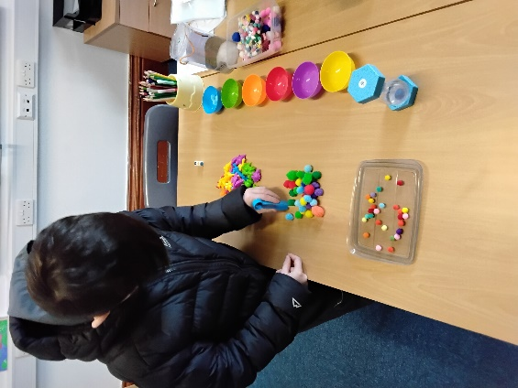
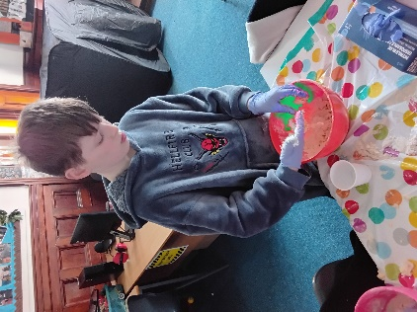
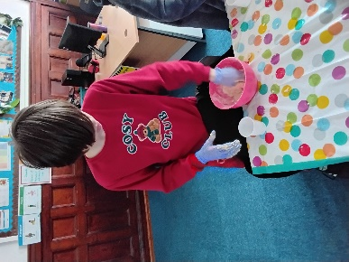
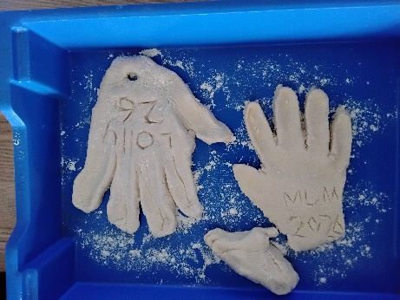
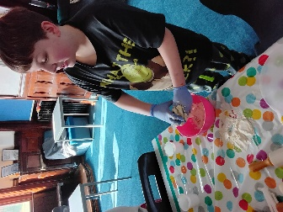
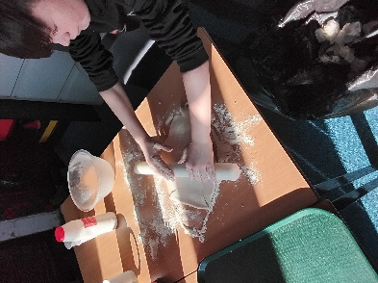
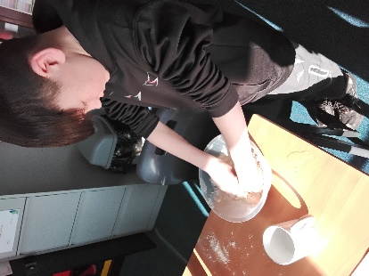
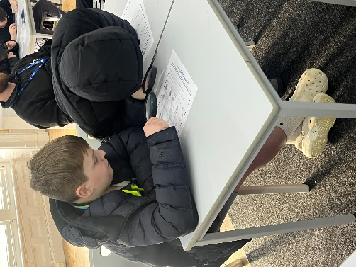
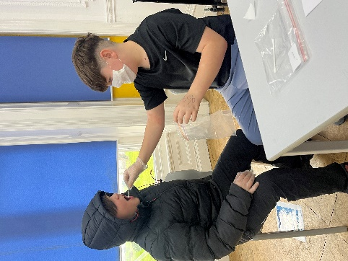
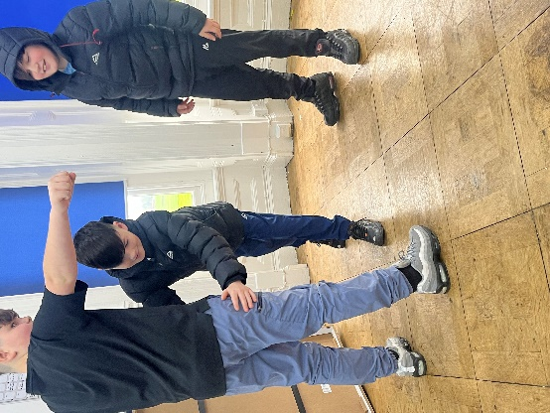
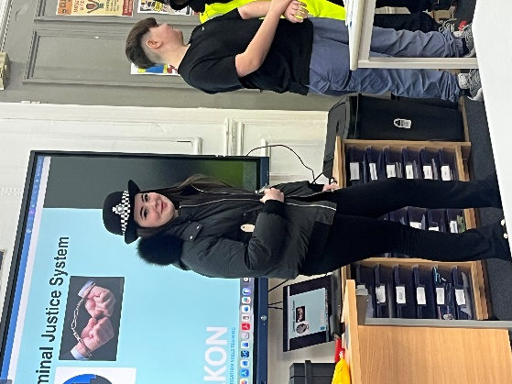
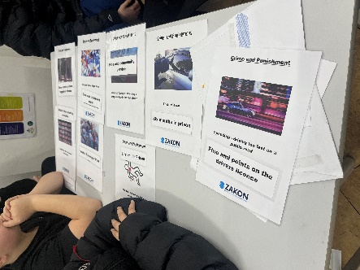
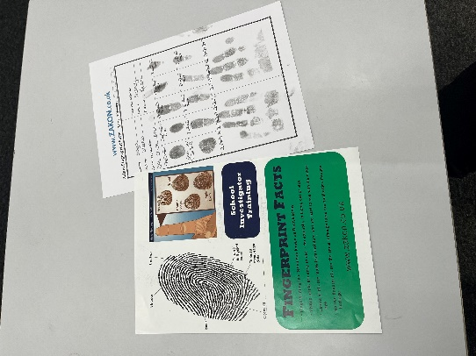
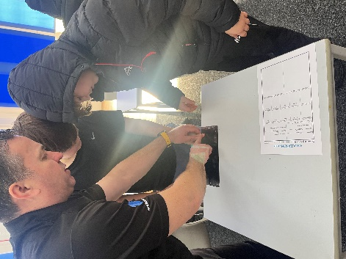
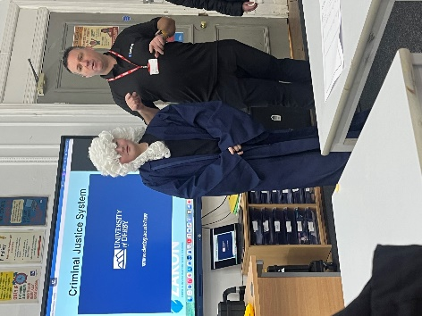
OUR COLOURFUL MATHS INTERVENTION SESSIONS HAVE BEEN A FANTASTIC WAY TO MAKE LEARNING FUN, ENGAGING AND ACCESSIBLE FOR OUR STUDENTS. USING BRIGHT RESOURCES, PRACTICAL ACTIVITIES AND HANDS-ON MATERIALS, PUPILS HAVE BEEN EXPLORING KEY MATHEMATICAL CONCEPTS SUCH AS COUNTING, NUMBER RECOGNITION, SORTING, PATTERNS AND SIMPLE PROBLEM SOLVING.

OUR SCIENCE INTERVENTION SESSIONS HAVE PROVIDED STUDENTS WITH EXCITING OPPORTUNITIES TO EXPLORE SCIENTIFIC CONCEPTS THROUGH PRACTICAL INVESTIGATION. PUPILS ENJOYED USING MICROSCOPES TO OBSERVE TINY DETAILS, HELPING THEM TO DEVELOP THEIR OBSERVATION SKILLS AND CURIOSITY ABOUR THE NATURAL WORLD.
AS PART OF OUR TARGETED INTERVENTION SESSIONS, STUDENTS RECENTLY TOOK PART IN ANACTIVITY WHERE THEY CREATED HANDPRINTS USING DOUGH. THIS HANDS-ON TASK PROVIDED AN ENGAGING WAY TO SUPPORT THE DEVELOPMENT OF KEY FINE MOTOR SKILLS WHILE ENCOURAGING CREATIVITY AND SELF-EXPRESSION.

THE WORKSHOP ALSO PROVIDED VALUABLE INSIGHTS INTO THE WIDE VARIETY OF CAREER PATHWAYS AVAILABLE WITHIN THIS FIELD, SUCH AS POLICE OFFICER, CRIME SCENE INVESTIGATOR, DATA ANALYST, AND OTHER SPECIALIST ROLES.

THIS TERM, WE WERE VISITED BY SIMON FROM ZAKON, AN EX-POLICE DETECTIVE WHO GIVES INFORMATIVE AND ENGAGING SESSIONS ON DIFFERENT CAREER PATHWAYS WITHIN THE POLICE FORCE AND CRIMINAL JUSTICE SYSTEM.

STUDENTS PARTICIPATED ENTHUSIASTICALLY THROUGHOUT THE DAY, DEMONSTRATING EXCELLENT ENGAGEMENT AND CURIOSITY. THEY ASKED THOUGHTFUL AND INSIGHTFUL QUESTIONS, SHOWING A STRONG INTEREST IN THE SUBJECT MATTER.

THROUGHOUT THE SESSION, STUDENTS WERE INTRODUCED TO A RANGE OF INVESTIGATIVE TECHNIQUES, INCLUDING FINGERPRINT ANALYSIS, DNA EXAMINATION, IDENTIFYING AND INTERPRETING CLUES, AND THE PROCESSES INVOLVED IN SEARCHING AND QUESTIONING SUSPECTS.

UPON SUCCESSFUL COMPLETION OF THE WORKSHOP, ALL STUDENTS WERE AWARDED CERTIFICATES IN RECOGNITION OF THEIR ACHIEVEMENT. OVERALL, IT WAS A HIGHLY SUCCESSFUL AND ENJOYABLE DAY THAT OFFERED STUDENTS A MEANINGFUL INTRODUCTION TO CAREERS IN POLICING AND FORENSIC INVESTIGATION.

VISITORS

