provider access policy
2023/24
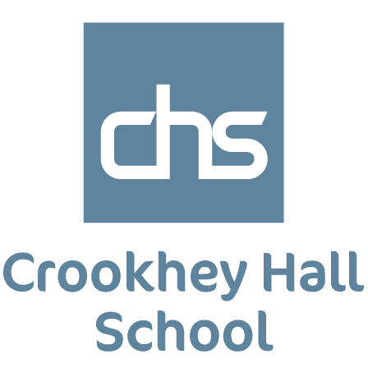

Crookhey Hall School: Provider Access Policy Statement
(To include The Department of Education, July 2021: “Baker Clause” and the Provider Access Legislation, January 2023)
Ownership: Crookhey Hall School
Date updated: September 2023
Rationale
High quality careers education and guidance in school or college is critical to young people’s futures. It helps to prepare them for the workplace by providing a clear understanding of the world of work including the routes to jobs and careers that they might find engaging and rewarding. It supports them to acquire the self-development and career management skills they need to achieve positive employment destinations. This helps students to choose their pathways, improve their life opportunities and contribute to a productive and successful economy.
As the number of apprenticeships rises every year, it becomes increasingly important that all young people have a full understanding of all the options available to them post-16 and post-18 including wider technical education options such as T-Levels and Higher Technical Qualifications.
Commitment
Crookhey Hall School is committed to ensuring there is an opportunity for a range of education and training providers to access students, for the purpose of informing them about approved technical education qualifications and apprenticeships. Crookhey Hall School is fully aware of the responsibility to set students on the path that will secure the best outcome which will enable them to progress in education and work and give employers the highly skilled people they need. That means acting impartially, in line with the statutory duty, and not showing bias towards any route, be that academic or technical.
Crookhey Hall School endeavours to ensure that all students are aware of all routes to higher skills and are able to access information on technical options and apprenticeships (The Department of Education, July 2021: “Baker Clause”: supporting students to understand the full range of education and training options, and the Provider Access Legislation, January 2023).
Aims
Crookhey Hall School policy for Access to other education and training providers has the following aims:
To develop the knowledge and awareness of our students of all career pathways available to them, including technical qualifications and apprenticeships.
To support young people to be able to learn more about opportunities for education and training outside of school before making crucial choices about their future options.
To reduce drop out from courses and avoid the risk of students becoming NEET (Young people not in education, employment or training).

Student Entitlement
Crookhey Hall School fully supports the statutory requirement for students to have direct access to other providers of further education training, technical training and apprenticeships. The school will comply with the new legal requirement to put on at least six encounters with providers of approved technical education qualifications or apprenticeships. This will be done in assemblies in National Apprenticeship Week and National Careers Week, in addition to providers attending careers events throughout the year.
Development
This policy has been developed and is reviewed annually by the Careers Leader and 14-19 Co-ordinator Claire Bolton and Laura Helme based on current good practice guidelines by the Department for Education.
Links with other policies
It supports and is underpinned by key school policies including those for Careers, Child Protection, Equality and Diversity, and SEND.
Equality and Diversity
Access to other providers is available and promoted to allow all students to access information about other providers of further education and apprenticeships. Crookhey Hall School is committed to encouraging all students to make decisions about their future based on impartial information.
Requests for access
Requests for access should be directed to Claire Bolton, Careers Leader. Mrs. Bolton may be contacted by telephone or email, Claire.bolton@crookheyhallschool.co.uk , Tel 07710 748084.
Grounds for granting requests for access
Access will be given for providers to attend during school assemblies, timetabled Careers or Life lessons, and Careers or Raising Aspirations events that The Crookhey Hall School is arranging. Students may also travel to visit another provider as part of the trip to be organised in partnership with Crookhey Hall School.
Details of premises or facilities to be provided to a person who is given access
The Crookhey Hall School will provide an appropriate room or assembly hall to be agreed. All rooms have computers, projectors and screens provided. Computer rooms can also be arranged. The Careers Leader or Careers Adviser will organise this, working closely with the provider to ensure the facilities are appropriate to the audience. Appropriate safeguarding checks will be carried out. Providers will be met and supervised by a member of the Careers Team who will facilitate.
Live/Virtual encounters
The Crookhey Hall School will consider live online encounters with providers where requested, and these may be broadcast into classrooms or the school assembly hall. Technology checks in advance will be required to ensure compatibility of systems.
Parents and Carers
Parental involvement is encouraged, and parents may be invited to attend the events to meet the providers.

Management
The Careers Leader coordinates all provider requests and is responsible to her senior management line manager.
Complaints Procedure
Any complaints about this policy should be raised to Claire Bolton, email: Claire.bolton@crookheyhallschool.co.uk
Claire Bolton will raise the complaint to Samantha Lea, Headteacher of Crookhey Hall School.
Monitoring review and evaluation
The Policy is monitored and evaluated annually via the Senior Leadership Team
Policy Coordinator: Claire Bolton
Policy Reviewed: September 2023
Appendix
Providers who have been invited into Crookhey Hall School to date include:
Lancaster & Morecambe College
Blackpool & Fylde College
Blackburn College
Preston College
Myrescough College
Destinations of previous pupils from Crookhey Hall School include:
Lancaster & Morecambe College
Blackpool & Fylde College
Blackburn College
Preston College
Myrescough College

