Crookhey Hall School
First Aid and Medication Policy

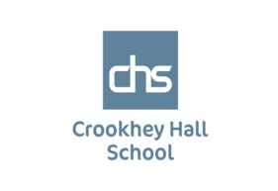

FIRST AID

It is the policy of Crookhey Hall School that there should be adequate and appropriate equipment, facilities and trained personnel to provide first aid within the school. First aid provision is available at all times while people are on the school premises, and also off the premises whilst on school visits.

Crookhey Hall School exceeds the minimum first aid provision suggested in the DfES “Guidance on First Aid for Schools”. The school provides suitably stocked first aid containers, in various places around school and in the first aid room. There are also an Emergency Eyewash Kit and a Body Fluid Disposal Kit in the SLT office.

Before undertaking any off-site activities first aid provision is considered and first aid kits are kept in the minibuses. All first aid containers are marked with a white cross on a green background.

At Crookhey Hall School there is always an appointed person on-site to take charge when someone is injured or becomes ill. Contact will be made with the pupil’s parent/carer to inform them of the situation and whether the pupil has been taken to hospital. Every endeavour will be made to get the parent/carer to the same hospital as the pupil.

School First Aiders

Appointed persons have emergency first aid training.

The Headteacher carries the responsibility for informing the school community of the first aid arrangements. Details of who are the first aid personnel and where they are to be found are displayed prominently. Staff and pupils are made aware of this information.

Staff take precautions to avoid infections and follow basic hygiene procedures. They have access to single-use disposable gloves and hand washing facilities and take great care when dealing with blood or body fluids and disposing of dressings or equipment. Whenever pupils are off-site engaging in adventurous activities an appointed person accompanies the group. Crookhey Hall School has a procedure which records all accidents and provides for the reporting of fatal or serious accidents, injuries etc. to the Health and Safety Executive and Acorn Education and Care.

The school records any first aid treatment given on-site and retains these records for inspection in the statutory accident book. Emergency contact numbers, and consent for medical treatment are obtained for all pupils. Parents/carers are informed of significant incidents in writing. First aid arrangements are the subject of regular and systematic checks.

When to Call 999

Any accident that is beyond First Aid assistance, including serious head injuries, excessive bleeding, unconsciousness or any other life-threatening situation, must be treated as an emergency and a call for ambulance assistance must be made. Action must be taken as soon as possible as haste is of the essence. The Headteacher must be informed and an incident recorded in RIDDOR.

Emergency Procedure for Major Incidents

In the event of such an emergency or if an ‘at risk’ pupil falls ill then the member of staff at the incident must:
1. Call 999
2. Summon a First Aider and get the relevant medication
3. Emergency treatment should be delivered.
¬ If phoning 999 the following information must be given:
• School Telephone Number: 01524 792618
• School Address: Crookhey Hall School, Garstang Road, Cockerham, Lancashire LA2 0HA
• Give your name
• Name of casualty and symptoms/any known medical condition
• Inform Ambulance control of the best entrance e.g. Main School Entrance,
• Person reporting the need of ambulance should stay on the telephone until informed by the operator they can hang up.
• If an ambulance is called the Reception and SLT should be informed and an adult should go to the notified entrance to give directions to the ambulance crew.
• The First Aider or responsible adult must accompany the casualty to hospital.
• If the emergency services are called the parent/carer of the casualty will be telephoned by the School Admin Office or a member of SLT as soon as is practicable.

Crookhey Hall School protocol for dealing with body fluid spillages

- General statement
The aim of this policy is to decrease the exposure risk to blood-borne and body fluid pathogens. Adherence to this policy is the responsibility of all staff that may come into contact with spillages of blood and other body fluids. All staff should be aware of their personal responsibilities in preventing the spread of infection.

- Legal position
The school has a duty to protect its staff from hazards encountered during their work: this includes microbiological hazards (COSHH 2002).

For the purposes of this policy, biohazards are defined as:
• Blood
• Respiratory and oral secretions
• Vomit
• Faeces
• Urine
• Wound drainage

- Prevention and preparation in case of spillage
• Workplace to provide a suitable assessment of the health risks associated with exposure to spillages of body fluids

• Staff to be aware of policy and risks associated with exposure to body fluids

• Provision of appropriate first-aid facilities and staff

• Materials for dealing with spillages to be readily available i.e. ‘spillage kits’ which are kept in the medical room.

• Regularly evaluate the procedure and update as necessary. Disinfection aims to reduce the number of micro-organisms to a safe level. All blood spills should be treated as a source of infection and dealt with according to strict hygienic principles.

- Management

If any type of body fluid has been spilled onto a surface the following precautions should be made:

• Notify appropriate staff i.e. cleaners, to secure the environment by placing warning signs.

• All staff dealing with a biohazard spill to wear protection i.e. - Disposable gloves - Disposable plastic apron - Eye and mouth protection with goggles and mask, if splash or spray anticipated

• Access ‘spillage kit’ in order to clean up spillage promptly. This pack contains: absorbent granules, disinfectant, scoop and scraper, disposable gloves, bags.

• Sprinkle granules over the spillage, completely covering it. This will solidify into a liquid in 2 minutes. Don’t stand over the solution as it can be a respiratory irritant.

• Using the scoop and scraper provided, remove the now solidified residue and place in a bio hazard bag, along with scoop and scraper. Dispose of in accordance with waste management regulations.

• Clean area and equipment thoroughly using hot water and detergent, and disposable cloths.

• Hand hygiene should be performed following management of spillage.

N.B. If a spill contains glass or sharps, these should be picked up with care into a sharps bin.

1. Rationale

Many pupils will need to take medication or be given it at school at some time in their school life. For most, this will be for a short period to allow them to finish a course of antibiotics or apply a lotion. In some cases, there may be a long-term need for pupils to take medication. To allow pupils to take or be given medication at school minimises the disruption that could be caused by illness and allows their education to proceed at a steady rate alongside their peers.

2. Aim

To work in partnership with parents, pupils, health professionals and other colleagues to ensure that children who require medication during school time are able to receive it in a safe and secure environment allowing them to continue to make progress at school and progress in their education.

3. Our Commitment

In common with good practice, we will aim to work in partnership with parents and (as appropriate) pupils to meet their individual needs. The following guidance aims to ensure a smooth-running partnership that minimises the impact of medical requirements on the day-to-day school life of pupils. Parents are encouraged to contact the Headteacher or member of the SLT if they feel that procedures require adjustment or alteration to suit their specific case.
Staff who provide support for pupils with medical needs which may include the administration of medication will be given support by the assistant Headteacher, access to necessary information, and receive appropriate training and guidance where necessary.

It is important that pupils who need to take medication at school are involved as closely as possible in the arrangements made for them. When planning for medical care at school the following should be considered:

• Independent management of needs
• Supervised administration of medication
• Staff administration of medication

Staff will assist pupils with their medical needs after consultation with the Headteacher. Agreements for administering medication will normally fall to the Headteacher after adequate consultation with parents and pupils. No staff member should enter into individual agreements with parent or child.

Crookhey Hall School will ensure that training is delivered according to guidelines.

Information about an individual pupil's medical condition and related needs will only be disseminated to relevant staff in order to ensure the pupil's well-being. Information can only be passed on with the consent of parents/carers.

Where there is concern about whether Crookhey Hall School can meet either a pupil's needs or the expectation of parents, the Headteacher will seek advice from the Local Authority and a suitable health professional.

A record will be completed for each pupil receiving medication in hard back book. The book includes the following information:

• The medicines required by the pupil,
• Details of dosage and times for administration,
• The types of medicines being carried,
• The staff involved in administration and supervision of medication.

Advice on the storage of medicines should be sought from a qualified pharmacist when required.

Medicines may be potentially harmful to anyone for whom they are not prescribed. We will try to ensure that risks to the health of others are properly controlled. A secure location is provided by Crookhey Hall School, this is in the medicine cabinet in the SLT office.

Medicine must only be brought to school in a suitable container. The container should be clearly labelled with the following information:

• Name of the pupil
• Name of the drug
• Dosage
• Frequency of administration.

Where a pupil needs two or more prescribed medicines, each should be in a separate container. Medicines should always be kept in their original containers.

Controlled medication will be kept in a locked container within the locked cabinet to ensure security is maximized. ALL STAFF WILL BE MADE AWARE UPON INDUCTION HOW AND WHERE TO OBTAIN APPROPRIATE KEYS.

When a medicine requires refrigeration, it can be kept in a refrigerator containing food, in an air-tight container. To avoid confusion medicines should be kept on a separate shelf used only for the storage of medication. The container should be clearly labelled as described above. If a refrigerator contains medicines, access to it should be carefully monitored. The refrigerator is situated in an area of Crookhey Hall School that is not normally accessible to pupils. Members of staff who use the refrigerator are made aware of the importance of keeping the medicine safe and secure.

In an emergency, pupils should have prompt access to their medicine through a recognised procedure. It is the duty of the Headteacher to ensure that all staff are familiar with the emergency procedure.

Crookhey Hall School staff will NOT dispose of medicines. Out of date medicines will be returned to parents / carers at the end of each term for disposal.

The Headteacher will ensure that staff know how to call the Emergency Services.

The schools Lead First Aider looks after the first aid containers and equipment and is responsible for re-stocking on a regular basis.

First Aiders have emergency first aid training. The Headteacher carries the responsibility for informing the school community of the first aid arrangements.

Staff will be made aware of medical conditions through SLT. They will be asked to look through consent forms to identify emergency procedures

A pupil who is taken to hospital by ambulance should be accompanied by a member of staff who will remain until the pupil's parent arrives at the hospital. If a pupil is taken to hospital, it is essential that Crookhey Hall School makes every effort to inform parents/carers immediately, failing this the emergency contact person will be informed.

In an emergency it may be necessary for a member of staff to take a pupil to hospital in his/her own car. The member of staff should be accompanied by another adult. When a pupil is taken to hospital by a member of staff they should also take with them all medication the pupil is currently taking together with the pupil’s medical record showing what medication has been taken, when it was taken and the dosage.

4. Working with parents

We will work together with parents to ensure that all relevant information with regard to a medical condition which may affect a pupil at school is passed on to all concerned. Information will only be requested from parents/carers when it is necessary to ensure the health and safety of the individual pupil and/or their peers at school. The confidentiality of a child's medical records will be respected. Information is gathered at induction meetings and regular reviews. Separate information is requested when a pupil is going off-site.

All parents/carers will be informed of Crookhey Hall School policy and procedures for addressing the medical needs of children. This information will be included in Crookhey Hall School induction pack.

Parents/carers should provide the Headteacher with adequate information about their child's medical condition, treatment, or any special care needed at Crookhey Hall School. They should, in partnership with the Headteacher, reach an agreement on Crookhey Hall School’s role in helping to address their child's medical needs. Any details will be passed on to those who need to know using the staff meeting forum.

The cultural and religious views of families should always be respected.

Parents/carers will be asked for the following information about medication:

• name of medicine
• dose
• method of administration
• time and frequency of administration
• other treatment which may involve Crookhey Hall School staff or affect the child's performance during the school day
• side effects which may have a bearing on the child's behaviour or performance at school

Pupil medical conditions will be established at the induction meeting. Parents should advise Crookhey Hall School of any changes in the medication administered to their child and or changes of their condition at the earliest opportunity.

5. Administration of Medicines

If a pupil refuses to take medication Crookhey Hall School will record this and inform the child's parents. If the medication is essential to the child's continued well-being, Crookhey Hall School will call the emergency services and inform the parents. If the medication is essential to the child being educated Crookhey Hall School will contact the parents to discuss actions to be taken.

STAFF MUST NOT COMPEL A PUPIL TO TAKE MEDICATION
Medication should be brought to Crookhey Hall School only when it is needed. Often medication can be prescribed in dose / frequencies which enable it to be taken outside school hours. Parents should be consulted about this.

Non-prescribed Medicines

Pupils sometimes ask for pain killers (analgesics) at school, including aspirin and paracetamol. Crookhey Hall School staff should generally not give non-prescribed medication to pupils; it may not be known whether the child has had a previous dose, whether the child is allergic to this drug, or whether the medication may react with another medication being taken.

With the prior agreement of parents/carers, Crookhey Hall School may administer mild analgesics; e.g. either one or two paracetamol tablets (according to parental/guardian advice/consent) to a child who asks for it, if they suffer pain or a headache at school. A record must be kept of the dose given and school will always contact parents/ carers for consent before this is administered

A child under 16 should never be given aspirin or medicines containing ibuprofen unless prescribed by a doctor.

Prescribed Medicines

Any member of staff giving medicines to a pupil should observe the following procedure in cooperation with a colleague:

• confirm the pupil's name agrees with that on the medication
• check the written instructions provided by the parents or doctor
• confirm the prescribed dose
• check the expiry date
• complete and sign the record book

Staff must complete and sign the medical log each time they give medication to a pupil.

Functional Medication

This type of medication includes medication includes; Insulin (diabetes), Ventolin (asthma), Diazepam / Valium (Epilepsy), Adrenaline (anaphylaxis). Where this type of medication is needed staff will be given specific training.

Sharps / Needles

Where pupils require medication, which is supplied with a syringe or epi-pen, or where blood needs to be tested, the staff must dispose of the needles appropriately. A bona-fide sharps box will be used for this purpose.

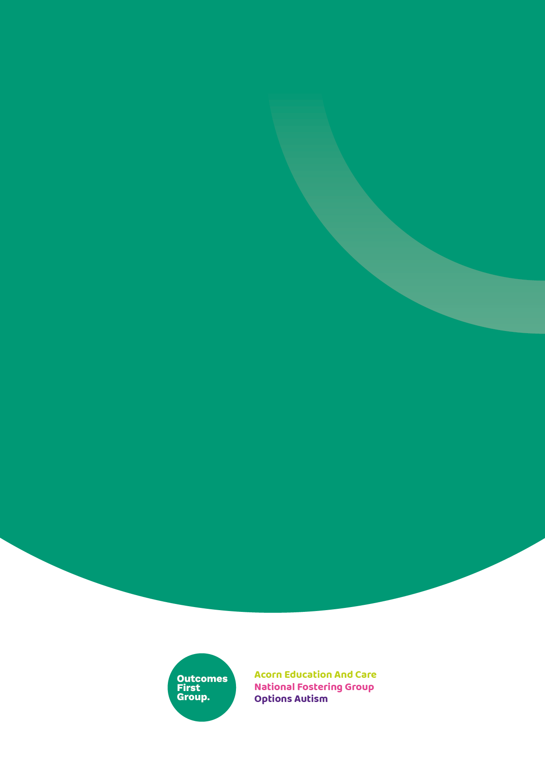

We are part of the Outcomes First Group Family, by working together we will build incredible futures by empowering vulnerable children, young people and adults in the UK to be happy and make their way in the world

