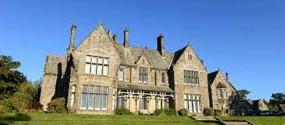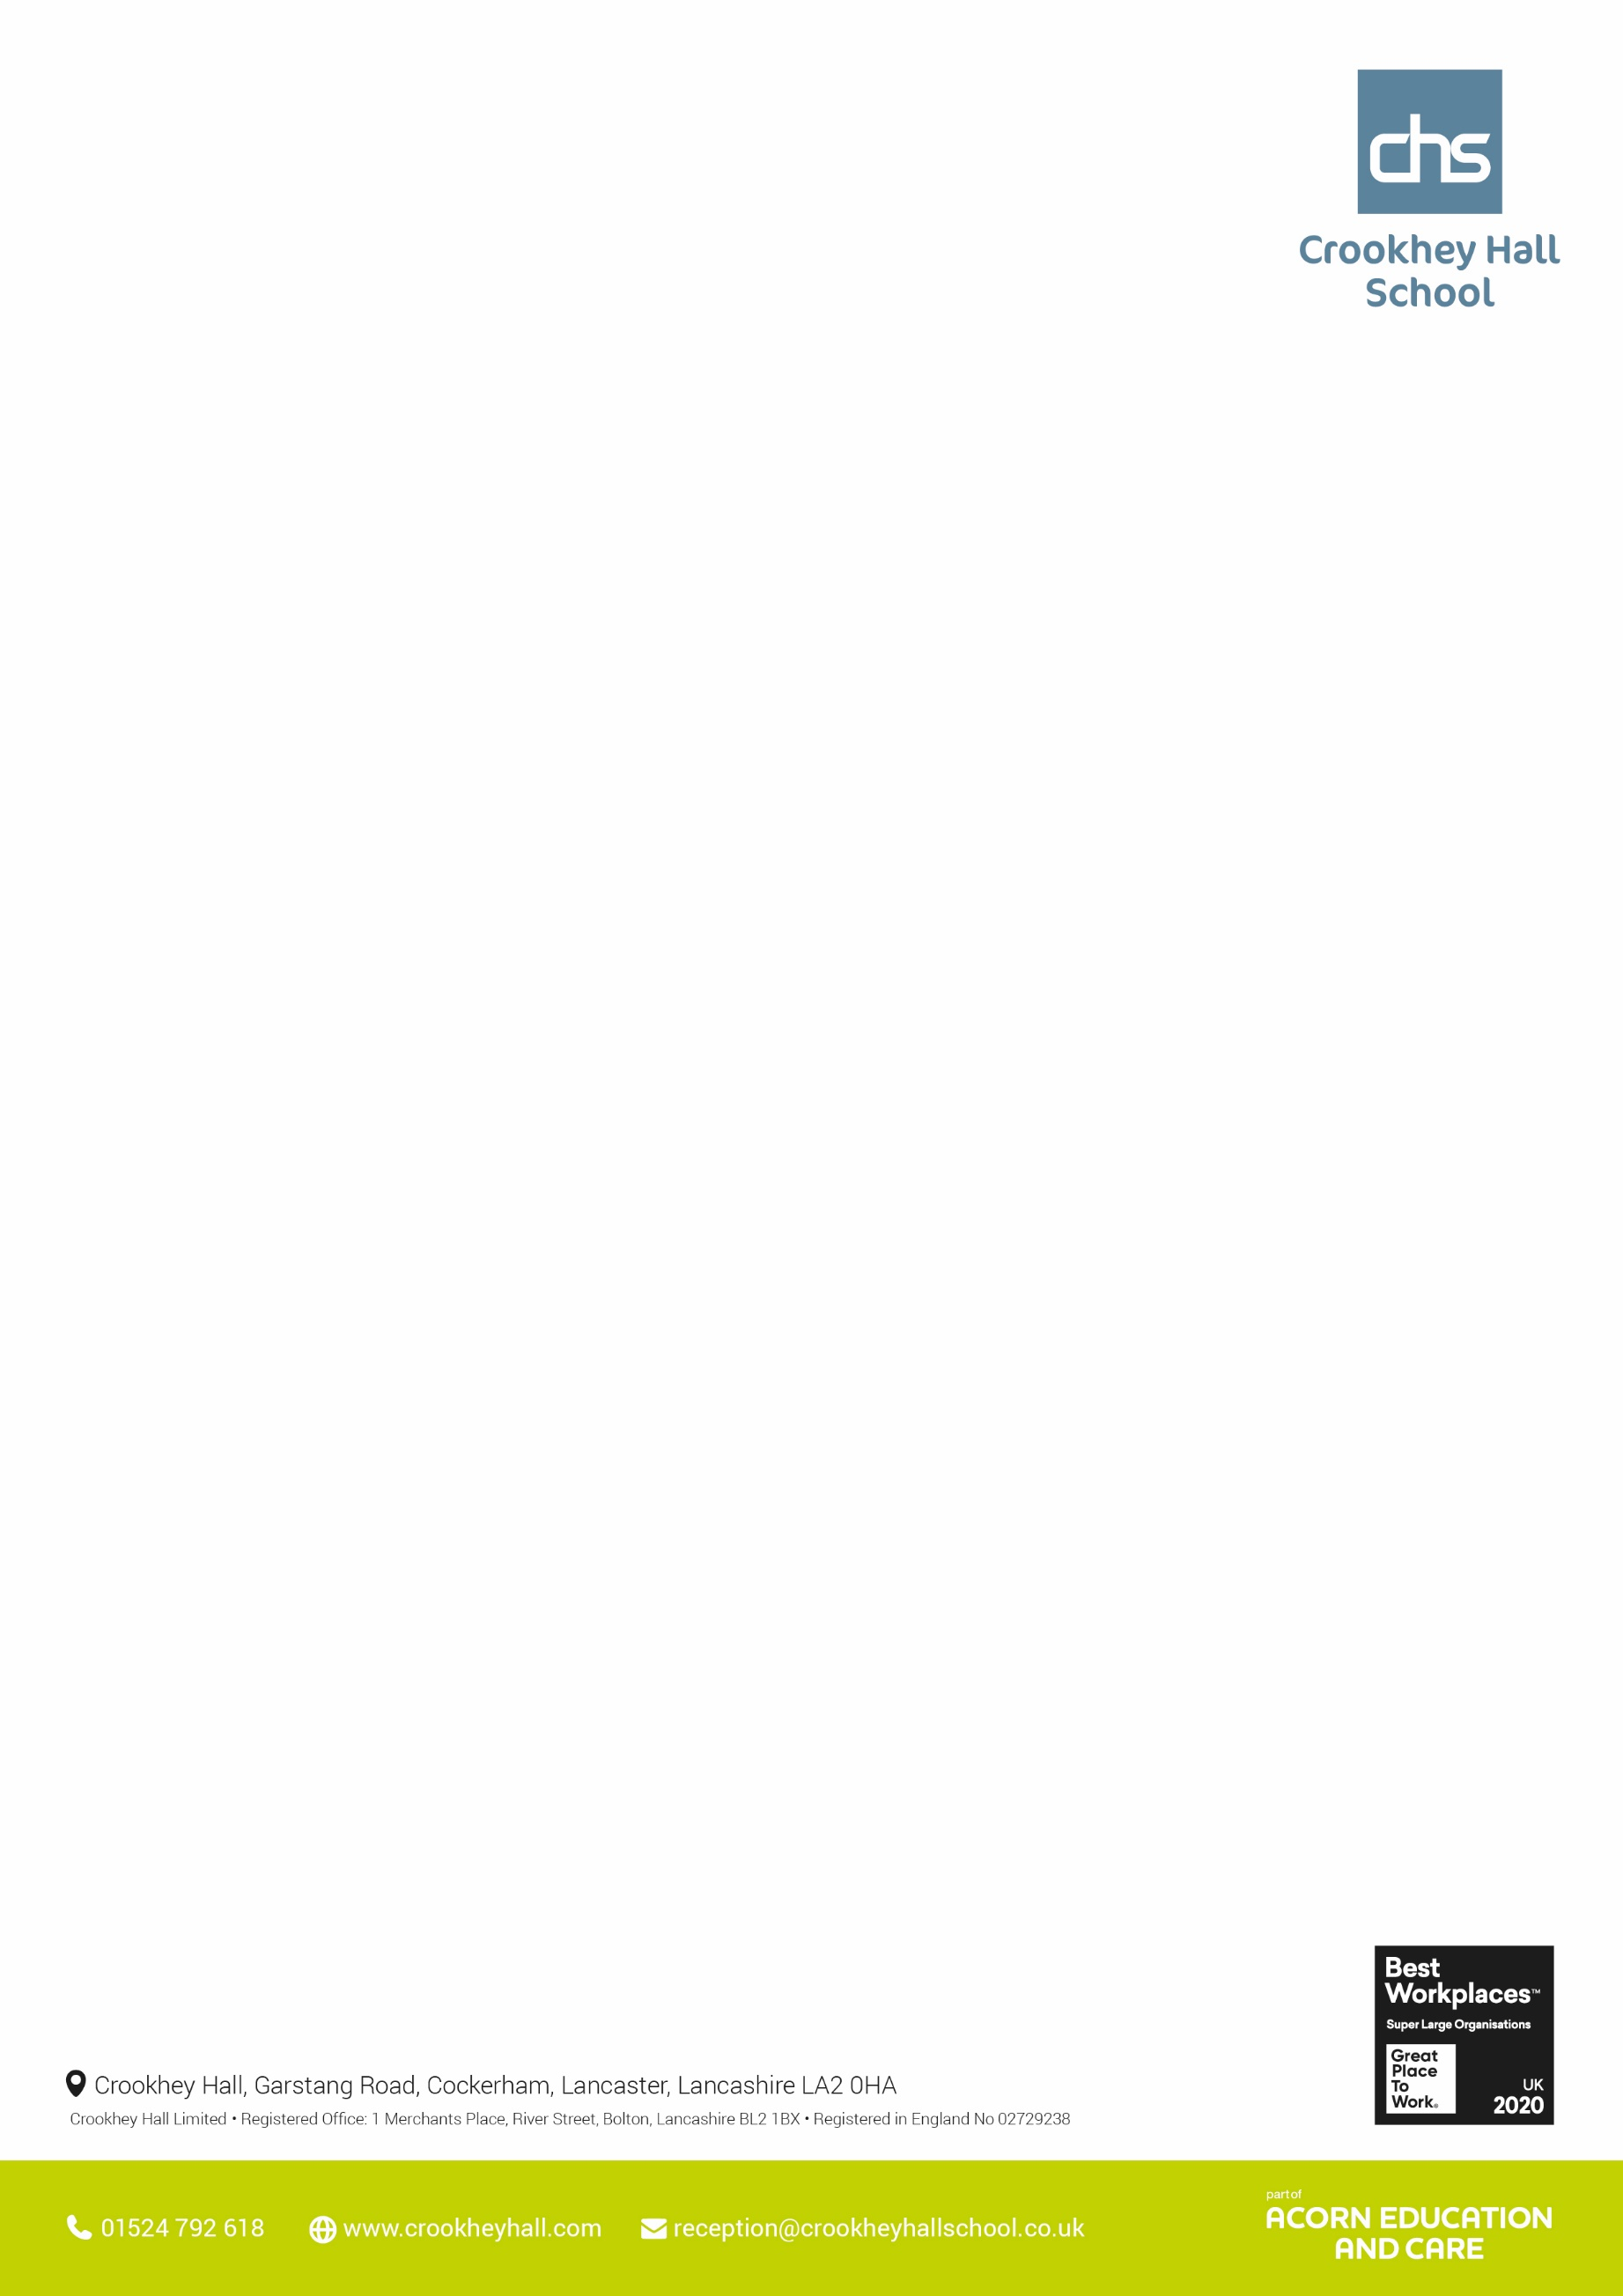

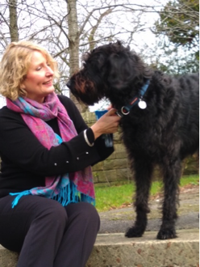

English - Year 10: Using an extract from Stephen King’s IT, Year 10 considered how writers use language to create suspense. With support, they began looking at the language devices writers use and how they affect the reader. They also considered how sentence structure impacts how the reader receives information and how this, too, can add to the suspense. Year 11, Class 1: Sat GCSE Paper 1 and revisited Paper 2- Approaches to the exam. Class 2&3: Some sat the GCSE and others continued to work towards their next Entry Level or Functional Skills Level.

Science - Year 10 Science: Pupils have been revisiting the topic of cells. Class 4 and 5 have moved on to diffusion. Class 6 have been exploring specialised cells. Year 11 Science: Pupils have been doing past paper questions and online quizzes in preparation for their final Biology GCSE exam on 9th June.

Maths - Class 1 – GCSE practice paper 2 and Paper 3, any individual topics for improvement. Class 2 – Entry Level 3 practice and papers and individual topics for improvement. Class 3- Solve financial maths problems. Class 4 – Baseline test, catch up and consolidation on missed work- subtraction and decimals. Class 5 – catch up and consolidation on missed work- subtraction and decimals, less progress than usual. Class 6 – entry level test, catch up and consolidation work -subtraction and decimals.

**Thought’s from the Head**

**Pictures from Upper School this week**

**PSHE** - Upper school have focuses on how discriminating against certain characteristics like sexual orientation or race can impact on how a person feels. They have individually explored a protected characteristic named in the Equality Act 2010 and discussed the difference between supporting that characteristic and discriminating against it.  **ICT** - This week the students have been discussing the purpose of ICT, why it provides useful skills for everyday living as well as in the office.  They have talked about the impact that AI and automation will have on future employment and industry as a whole. **Art** Year 11: Students have completed the GCSE course and are now using this time to revise other subjects and develop skills in other areas. **Catering** Year 9: Students are developing their weighing and measuring skills through cake baking. **History** - Year 10 have started their site study on Lancaster Castle as part of their third and final unit of the Entry Level Certificate. **Construction** - years 10 & 11 are now completing and adding finishing touches to the qualification units ready for them to be sent away for examination this month. **Horticulture** - We have completed the latest poultry pen this week, ready for our expected hatching chicks. We have also made a start on our next major project which is going to be a decorative water feature.

**Upper School – Other areas**

**Upper School – Core subjects**

**Wc 5th June 2023**



**Wc 5TH June 2023**

**Lower School – Other areas**

English - Year 7 have started their unit on Speaking and Listening. Year 8 have started their unit on Shakespeare and his plays. Year 9 have started studying the Shakespeare play 'The Taming of the Shrew'

Science - Year 7 - We have introduced our new topic of Animals and their habitats. We started by understanding how animals are classified and how this relates to how zoo's operate. Year 8 - We have started our topic on the skeletal system. We have investigated the different main, scientific bones in our body and how they protect our organs. Year 9 - We have started our topic on nutrition and digestion. This involved investigating the different nutrient groups to begin with, looking at what makes a healthy diet and how to create a healthy, varied meal plan for a week.

Maths - This week year 7 have been looking at comparing and ordering angles as well as using angles to describe turns. This week year 8 have been learning to understand negative numbers and using their knowledge of negative numbers to compare and order them. This week year 9 have been working with numbers up to 1,000,000 and 10,000,000 developing their skill of using powers of 10.

**Lower School – Core subjects**

**Pictures from Lower School this week**

PSHE - Lower school have been exploring discrimination and how this can impact emotional wellbeing. This has continued with the work on the equality act 2010 and the protective characteristics named in the act.

Art – Year7 Students learnt how to create symmetrical single layer stencils and apply spray paint to create artwork. Year 8 Art: Students have been looking at a timeline of Art History. This week we have been delving into Abstract Expressionism through expanding upon artists works. Year 9 Art: Students are looking at Pop Art and have been expanding upon Pop Artwork by a range of famous artists including Andy Warhol and Roy Lichtenstein.

Catering Year 9: Students are developing their weighing and measuring skills through cake baking.

Construction - lower blocks as continued with their projects and prizes for the summer fair.

Humanities - Year 7 pupils looked at the holy trinity and what it means to Christians while focusing on the war of the roses History. Year 8 have been examining the differences been the Arctic and the Antarctic for geography whilst question the ethics of Zoos in RE. Year 9 have been local at the impact of the global economy on the quality of life. where their RE lessons have looked at religion, crime and punishment.

Outdoor Education - all groups started the 6-week course for climbing and bouldering at west view leisure centre. All groups took part and put in effort.

ICT - all groups have been discussing newsletters, what they are and how they are designed. By the end of the term all pupils will have created their own newsletters on a topic that they have chosen.