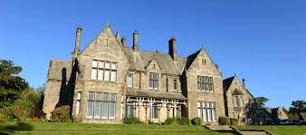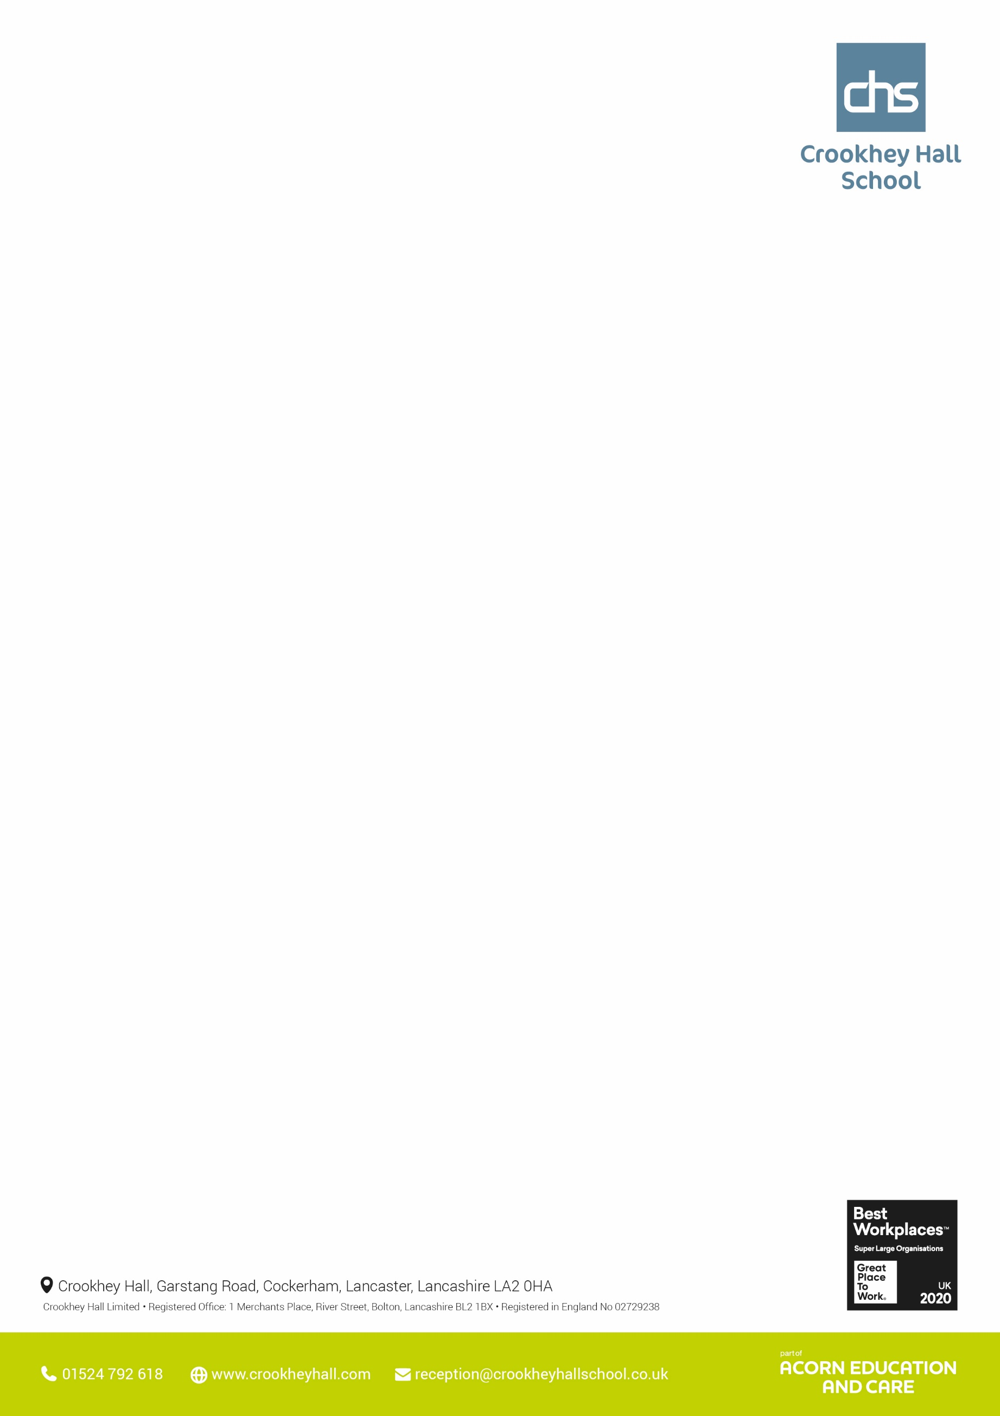

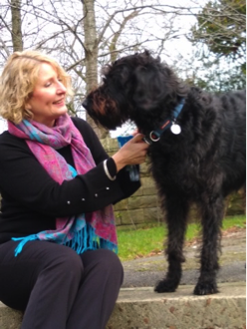

Science Year 10 Science: Pupils have been learning how to use a punnet square, predicting probability, how gender is inherited and about genetic conditions and how they are inherited including Polydactyly (classes 4,5 and 6) and Cystic Fibrosis (class 6).

Year 11 Science: Pupils have been mainly focussing on Entry Level Certificate papers. With many successful achievements made this week.

Maths Class 1 – Functional Level 1 practice papers and exams, fractions of amounts, ordering and comparing decimals, rounding to decimal places, Entry level 2 exam, Entry level 3 practice papers Class 2- Entry Level 3 – Rounding 3 and 4-digits, rounding functional questions, checking answers by estimating numbers, properties of 2D shapes and lines of symmetry Class 3 - Entry Level 3 – Rounding 3 and 4-digits, rounding functional questions, checking answers by estimating numbers Class 4,5, 6– Squares and square roots, cubes and cube roots, inverse operation, higher powers, calculating with index notation including calculator skill

English Class 1- Practised Paper 1, Q2 by considering how Steinbeck presented the conflict at the opening of, “The Pearl.”Class 2,4,5 and 6- Began looking at Functional Skills tasks through a piece of work based around Marvel Comics. Students have completed reading comprehension and layout tasks as well as creating their own characters and began planning a letter to persuade Marvel executives to use feature their character in a comic.

Class 3- Continued to work on literacy and comprehension. Each pupil worked on tasks specific to their needs.

**Thought’s from the Head**

***The other day I was walking along the beach when I noticed a young boy picking something off the sand and throwing it into the sea. As I got closer, I realised the child was throwing stranded starfishes that had washed up on the shore back into the waves. I asked the boy what he was doing. “The starfish will die if they’re still On the shore when the sun rises,” he replied. I was a bit unsure and said, “But that’s pointless! This is a massive beach and thousands of starfish. It doesn’t matter how many you return to the water, you can’t make a difference. ”The boy just looked at me, bent down, picked up another starfish, and tossed it into the sea. “It matters to this one,” he said. Moral of the story: No matter the odds of success or the scale of the challenge, your actions can make a difference. It’s better to light a candle than complain about the dark. Every little counts. Doing something to make a positive change is always better than nothing!***

**Pictures from Upper School this week**

Humanities

Year 10 have been looking at the Mercian Uprising and the English response after the battle of Hastings. Year 11 have finished their ELC in History this week having completed their write up of Lancaster Castle as part of the site study.

PSHE

Year 10s have continued to plan their external learning opportunities and made contact with Manchester City Stadium to see what they can offer for a day trip.

This week our year 11s have completed some BTEC catch up sessions so that they have completed the majority of their unit work to be signed off. Most of them have excelled in this and should be proud of how much knowledge they have gained in emotional wellbeing and resilience.

Construction / Woodwork:

Year 10 & 11 groups have continued to work on units A2 (smart targets) which they have all completed to a good standard + con 10 & 14.

Law:

Looking at the range of sentences and how they seem appropriate or disproportionate to the offences.

Year 11 Art: The students have been completing the 10 Hour GCSE Art exam.

Woodwork

Years 9,8,7 & rotational groups have continued with their AQA awards for making a self-standing planter & making a wooden planter box or a project of their own choice, all classes are making great progress

**Upper School – Other areas**

**Upper School – Core subjects**

**Wc 24th April 2023**



**Wc 24th April 2023**

**Lower School – Other areas**

English

Year 7 have been focusing on acrostic poems.

Year 8 have been looking at the connections between songs and poetry.

Year 9 have been considering the term culture and what it means to them.

Science

Year 7 - We have continued to focus on the importance of understanding each symbol when drawing a circuit. They have done really well and are now confident at identifying the correct product to the symbol. We are now focusing on identifying the potential problems in a circuit and understanding how we can build safe circuits.

Year 8 - This has been a challenging topic to understand for many pupils, but they are making progress in understanding how the rock cycle works. They can identify different types of rock and can explain the different layers underneath the Earth's crust. We are moving onto the Earth's atmosphere and what can affect this.

Year 9 - They are building on from the knowledge they gained last term in chemistry to apply it to this term's states of matter unit. They have made a confident start in this topic and can recall different states of matter, what affects them and whether they are reversible or irreversible changes. We are now focusing on the energy of different particles.

Maths

Year 7s and 8s have been exploring time and angles on a straight line whilst year 9s continue to explore shapes.

**Lower School – Core subjects**

**Pictures from Lower School this week**

Humanities

year 7's are learning about the polar regions and are amazed that penguins and polar bears have never met. in RE they are looking at Islam and the similarities of other religions.

Year 8's are learning about how Britain colonised the Americas and didn't realise that Pocahontas was a real person. in RE they are questioning the existence of God. Year 9 are learning about the events in WW2 and couldn't understand why an arial battle between two planes was called a dogfight. this ties in very well with their RE lessons which is looking at religion, peace and conflict.

PSHE

Year 7, 8 and 9 have continued to explore puberty and will move on to reproduction.

ICT

This week the students have been revisiting Excel and honing their worksheet skills.  Excel is a very useful piece of software and, once set up, can be a real work saver when it comes to accounting etc

Construction / Woodwork:

Years 7, 8, 9 & rotational groups have continued with their AQA awards for making a self-standing planter & making a wooden planter box or a project of their own choice, all classes are making great progress.

Year 9 Art: The students have been using spray paint and ink to create bold prints of their name.Year 8 Art: The students have been creating outer space scenes with spray paint.Year 7 Art: The students have been creating artist research pages on Leonora Carrington, a famous surrealist artist who used to live at Crookhey Hall.