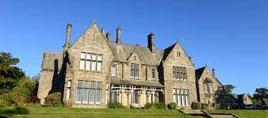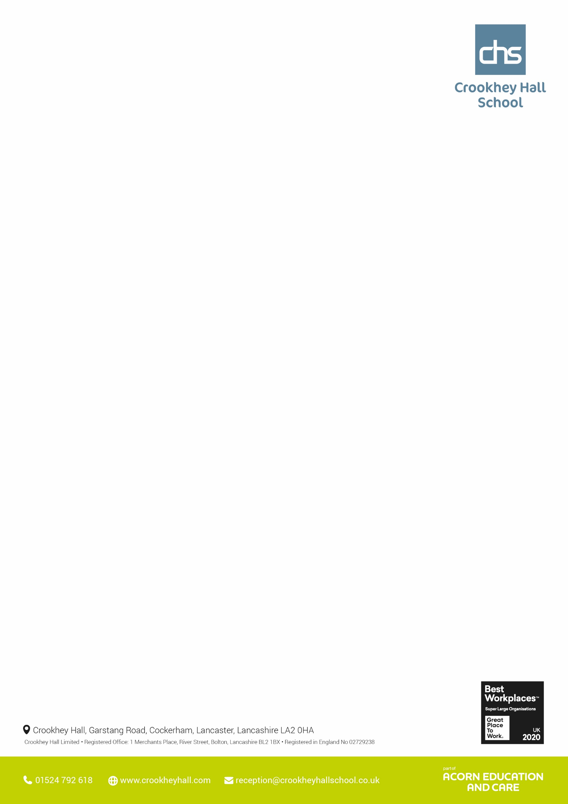

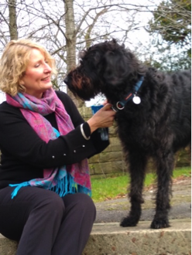

Science - Year 10 have been finishing off the topic of inheritance, variation and evolution by looking at the advantages and disadvantages of selective breeding and genetic engineering. The have finished off the week by completing their Entry Level Certificate paper 1 on Cells, genetics, inheritance and modification. Year 11 have been practicing past paper questions and using laptops to aid their revision with online learning.

Maths - Class 1 – GCSE practice paper 2, and individual topics for improvement. Class 2 – 8-point Compass & directions, Entry Level 3 practice and papers Class 3- Fractions. Class 4 – Subtracting integers, adding decimals, subtracting decimals using formal method. Class 5 – subtracting integers and subtracting decimals formal method. Class 6 – adding decimals, subtracting integers and decimals formal methods.

English - Class 1- Full walk through of Paper 1 with specific focus on strategies for question 5. Class 2, 3, 4, 5- Individual tasks. Pupils have completed Entry Level qualifications but continue to work towards their next level in preparation for their next steps in education. All students are working towards either Entry Level 3 or Functional Skills Level 1.

**Thought’s from the Head**

**Pictures from Upper School this week**

In law, we have looked at the various levels of police and what sector there are in the force.

Year 10 life skills have been spending this week doing some team building skills in preparation of having to plan activities for the Summer Fayre and being able to work as a team

ICT - This week the students have continued to focus on Microsoft Excel and learning to use the autofill and autosum features.

Outdoor Ed – Various different activities for the groups this week. Exploring Happy mount park in Morecambe, swimming - Salt ayre leisure centre, archery, 315 Gym and Morecambe promenade walking

In History this week, Year 10 have been examining the rise of Adolf Hitler as part of their research into him for their next unit, a biography of Hitler and his impact.

Land based studies - This week we have been working on a new chicken pen and a breeding enclosure for our finches.

PSHE - Year 10 and 11s have started to look at topics which take their interests for next term and have researched, drug and alcohol abuse which is what they will start to explore next term. Construction - years 10 & 11 have now completed the block pathing area outside the intervention room for unit con 14

**Upper School – Other areas**

**Upper School – Core subjects**

**Wc 22nd May 2023**



**Wc 22nd May 2023**

**Lower School – Other areas**

Science - Year 7 - They have reached the conclusion of their electrical circuit's topic. They have looked at electrical insulators and conductors and how everyday appliances are made safer for us to use. They have been fantastic in this topic all term. Year 8 - We are understanding the affects of acid rain and climate change - whilst also completing a small topic in Biology to do with variation. This has come together nicely through investigating Charles Darwin in the Galapagos Island's, and how climate change is affecting the animals there. Year 9 - They have attempted their Entry Level paper for this topic after spending the last couple of weeks working hard in this topic to prepare for it. They have done well persevering with complex terminology and difficult sub topics within this States of Matter topic.

English - Year 7 have been completing an AQA Unit Award about Blackout Poetry. Year 8 have been prepping for Speaking and Listening activities. Year 9 have been studying the connection between classic texts and poetry.

Maths - Year 7 - This week year 7 have been assessing their knowledge of plotting coordinates and describing position using coordinates on my maths and IXL. Year 8 - This week year 8 have been assessing their knowledge of properties of 3-D shapes on my maths and IXL. Year 9 - This week year 9 have been assessing their knowledge of divisibility on my maths and IXL.

**Lower School – Core subjects**

**Pictures from Lower School this week**

Humanities - Year 7 have looked at life after death in Islam while examining the lives of the Nenets in the Arctic. Year 8 Have looked at the ways early colonists of India and the Americas made their wealth while also examining different religious views on life after death. Year 9 have continued with World War 2 with the D day landings being the topic. RE focused on pacifism and how most religions preach peace.

ICT - All pupils were able to understand how to send and receive emails and what the icons are used for when sending emails.

PSHE – Year 7, 8 and 9 have been focusing on discrimination and protective characteristics.

Vocation **-** lower blocks as continued with their projects and prizes for the summer fair.