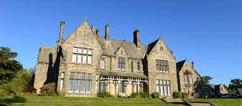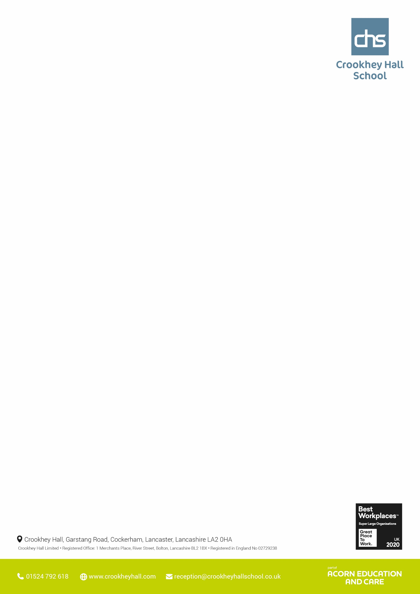

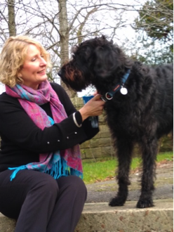

**Science:** Year 10: All classes have been looking at the theory of Evolution by Natural Selection and exploring the evidence collected by Charles Darwin to back up the theory. Pupils have then gone on to look at Selective breeding by creating their own mutant that is capable of specific skills using parents from the X-Men film series. Year 11: Those entered for GCSE have sat their first Biology paper on Tuesday. Entry level certificate has now finished as the deadline has passed and the papers are now to be sent off for moderation. Pupils are now practicing past paper questions for Biology paper2.   **Maths:** Class 1- GCSE practice paper and topic books. Class 2- GCSE practice papers and Entry level topics. Class 3- Entry level 3 papers, 8 point compass, movement and direction vocabulary. Class 4- Formal methods of integer addition 3 and 4-digit, formal methods of adding decimals, Entry level papers. Class 5- Mental strategies of addition – compensation method, Formal methods of integer addition 3 and 4-digit. Class 6- Mental strategies of addition – compensation method, Formal methods of integer addition 3 and 4-digit **English**: Class 1- have considered how writers use structure to influence and direct the reader in preparation of Paper 1 Q3. They have verbalised how they would respond to possible questions posed in the exam and evaluated model responses. Class 2- have completed independent work targeted at their next level of functional skills. Those with outstanding elements of Functional Skills assessments have continued to undertake them.Class 3- have completed independent literacy tasks and group speaking and listening activiti. Class 4, 5, 6- have adapted job application letters from informal language to formal language. They have considered how this effects tone and how tone should be considered depending on who you are speaking/writing to and the purpose of the writing.

**Thought’s from the Head**

A well known member of staff at Crookhey Hall began a lesson by showing the class a crisp £20 note. She asked, “Who wants this £20 note?”. The whole class shouted out “Me, me.” She said, “I am going to give this money to someone, but first….”. Then she proceeded to crumple the note up in her fist. She asked her class again if anyone wanted it. The whole class shouted out “Me, me” again. The member of staff then dropped the money on the floor and stomped all over it. She then held it up in the air to show the pupils.

The money was filthy. “Does anyone want it now?” she asked. Every pupil put their hand up. “Well,” she said “no matter what I do to ruin this money, you still want it because its value remains the same, it is still worth £20.” The Moral of this story: Life often beats us up to the point where we feel inadequate. We deal with bad circumstances and make poor choices that we have to deal with later. However, no matter what you go through, your value will remain the same. You all have something special to offer that ***no one*** can take away from you. 😊

**Pictures from Upper School this week**

**ICT**: This week the students have been working in teams and constructing various buildings in the virtual world of ‘Minecraft.’  This encourages good communication and cooperation in a safe but fun environment and utilises language, science, geographical and mathematical skills as well as ICT.

**Catering:** Year 10 Catering: The students used whole spices to make a Suriani chicken curry and rice. Year 11 Catering: : The students used whole spices to make a Suriani chicken curry and rice

**PSHE:** Year 10 and 11 have continued to explore discrimination before moving onto an introduction to banking. This included a brief introduction to banks, statements and how a bank functions.

**Humanities**: Year 10 have started their third unit in ELC History. This is a study of a historic person, with the pupils having chosen Adolf Hitler as their chosen individual.

**Horticulture:** In horticulture this week we have been going out and speaking to local builders. As a result we have managed to get 5 tonnes of good quality topsoil for free! The pupils have been working rally hard moving it all into the new raised beds.

**Upper School – Other areas**

**Upper School – Core subjects**

**Wc 15th May 2023**



**Wc 15th May 2023**

**Lower School – Other areas**

**Science:** Year 7 - We have been continuing to investigate circuits. We have now been focusing on understand comprehension tasks, using those skills to understand circuits in sentence form and answering questions based on this. Year 8 - We have moved on to a small Biology topic investigation variation. We have started by investigating Charles Darwin's theory in the galapagos islands. Year 9 - We are looking at the history of the atom. How this had changed over time and how the periodic table was formed. This will aid their ELC next week.

**Maths**: Year 7 - This week year 7 have been consolidating their knowledge of money, using pounds and pence and practising writing money as a decimal. They then have applied this to help develop their ability to round decimals to the nearest whole in order to estimate total costs of select items. Year 8 - This week year 8 have been looking at multiplying and dividing by 10, 100 and 1000 focusing on decimals and practising increasing and decreasing the place values of the digits using place value charts. Year 9 - This week year 9 have been building on top of their understanding of coordinates but this time in all four quadrants; translating points and shapes on the coordinate grid.

**English:** Year 7 have been focusing on interpretating the story of a poem. Year 8 have been focusing on extended metaphors within pop songs (Poetry unit). Year 9 have been studying the use of personification in Anthology poems.

**Lower School – Core subjects**

**Pictures from Lower School this week**

**Art:** Year 7 Art: The students developed their acrylic painting skills on canvas, inspired by Leonora. Year 8 Art: The students turned their graffiti typography of their name into a  two part stencil. Year 9 Art: The students created stencils based on the work of graffiti artist Banksy.

**PSHE:** Year 7 8 and 9 have been focusing on reproduction and how this links to puberty. They explored how the reproductive organs function and how this is impacted by puberty.

**Humanities**: Year 7 are continuing with Islam and the idea of Predestination, determinism and free will. the geography module is looking at plant adaptations to arctic conditions. Year 8 have been looking at life after death in RE. with regards to History they have been examining the East India company's impact on India. Year 9 have been focusing on Pearl Harbour and how the event changed the course of WW2 and this also ties in with their RE subject of religion, peace and conflict which examined religious views on nuclear weapons.

ICT- All groups understood how to send and receive emails and then sent the emails that were written in their books and typed them and sent to Miss Pollard.

**Outdoor Ed:** Some groups went to happy mount park for orienteering for outdoor education positive interaction within a public setting. The rest of the groups went to archery and continued their 6-week session programme.