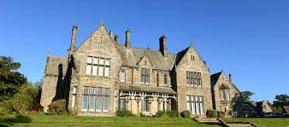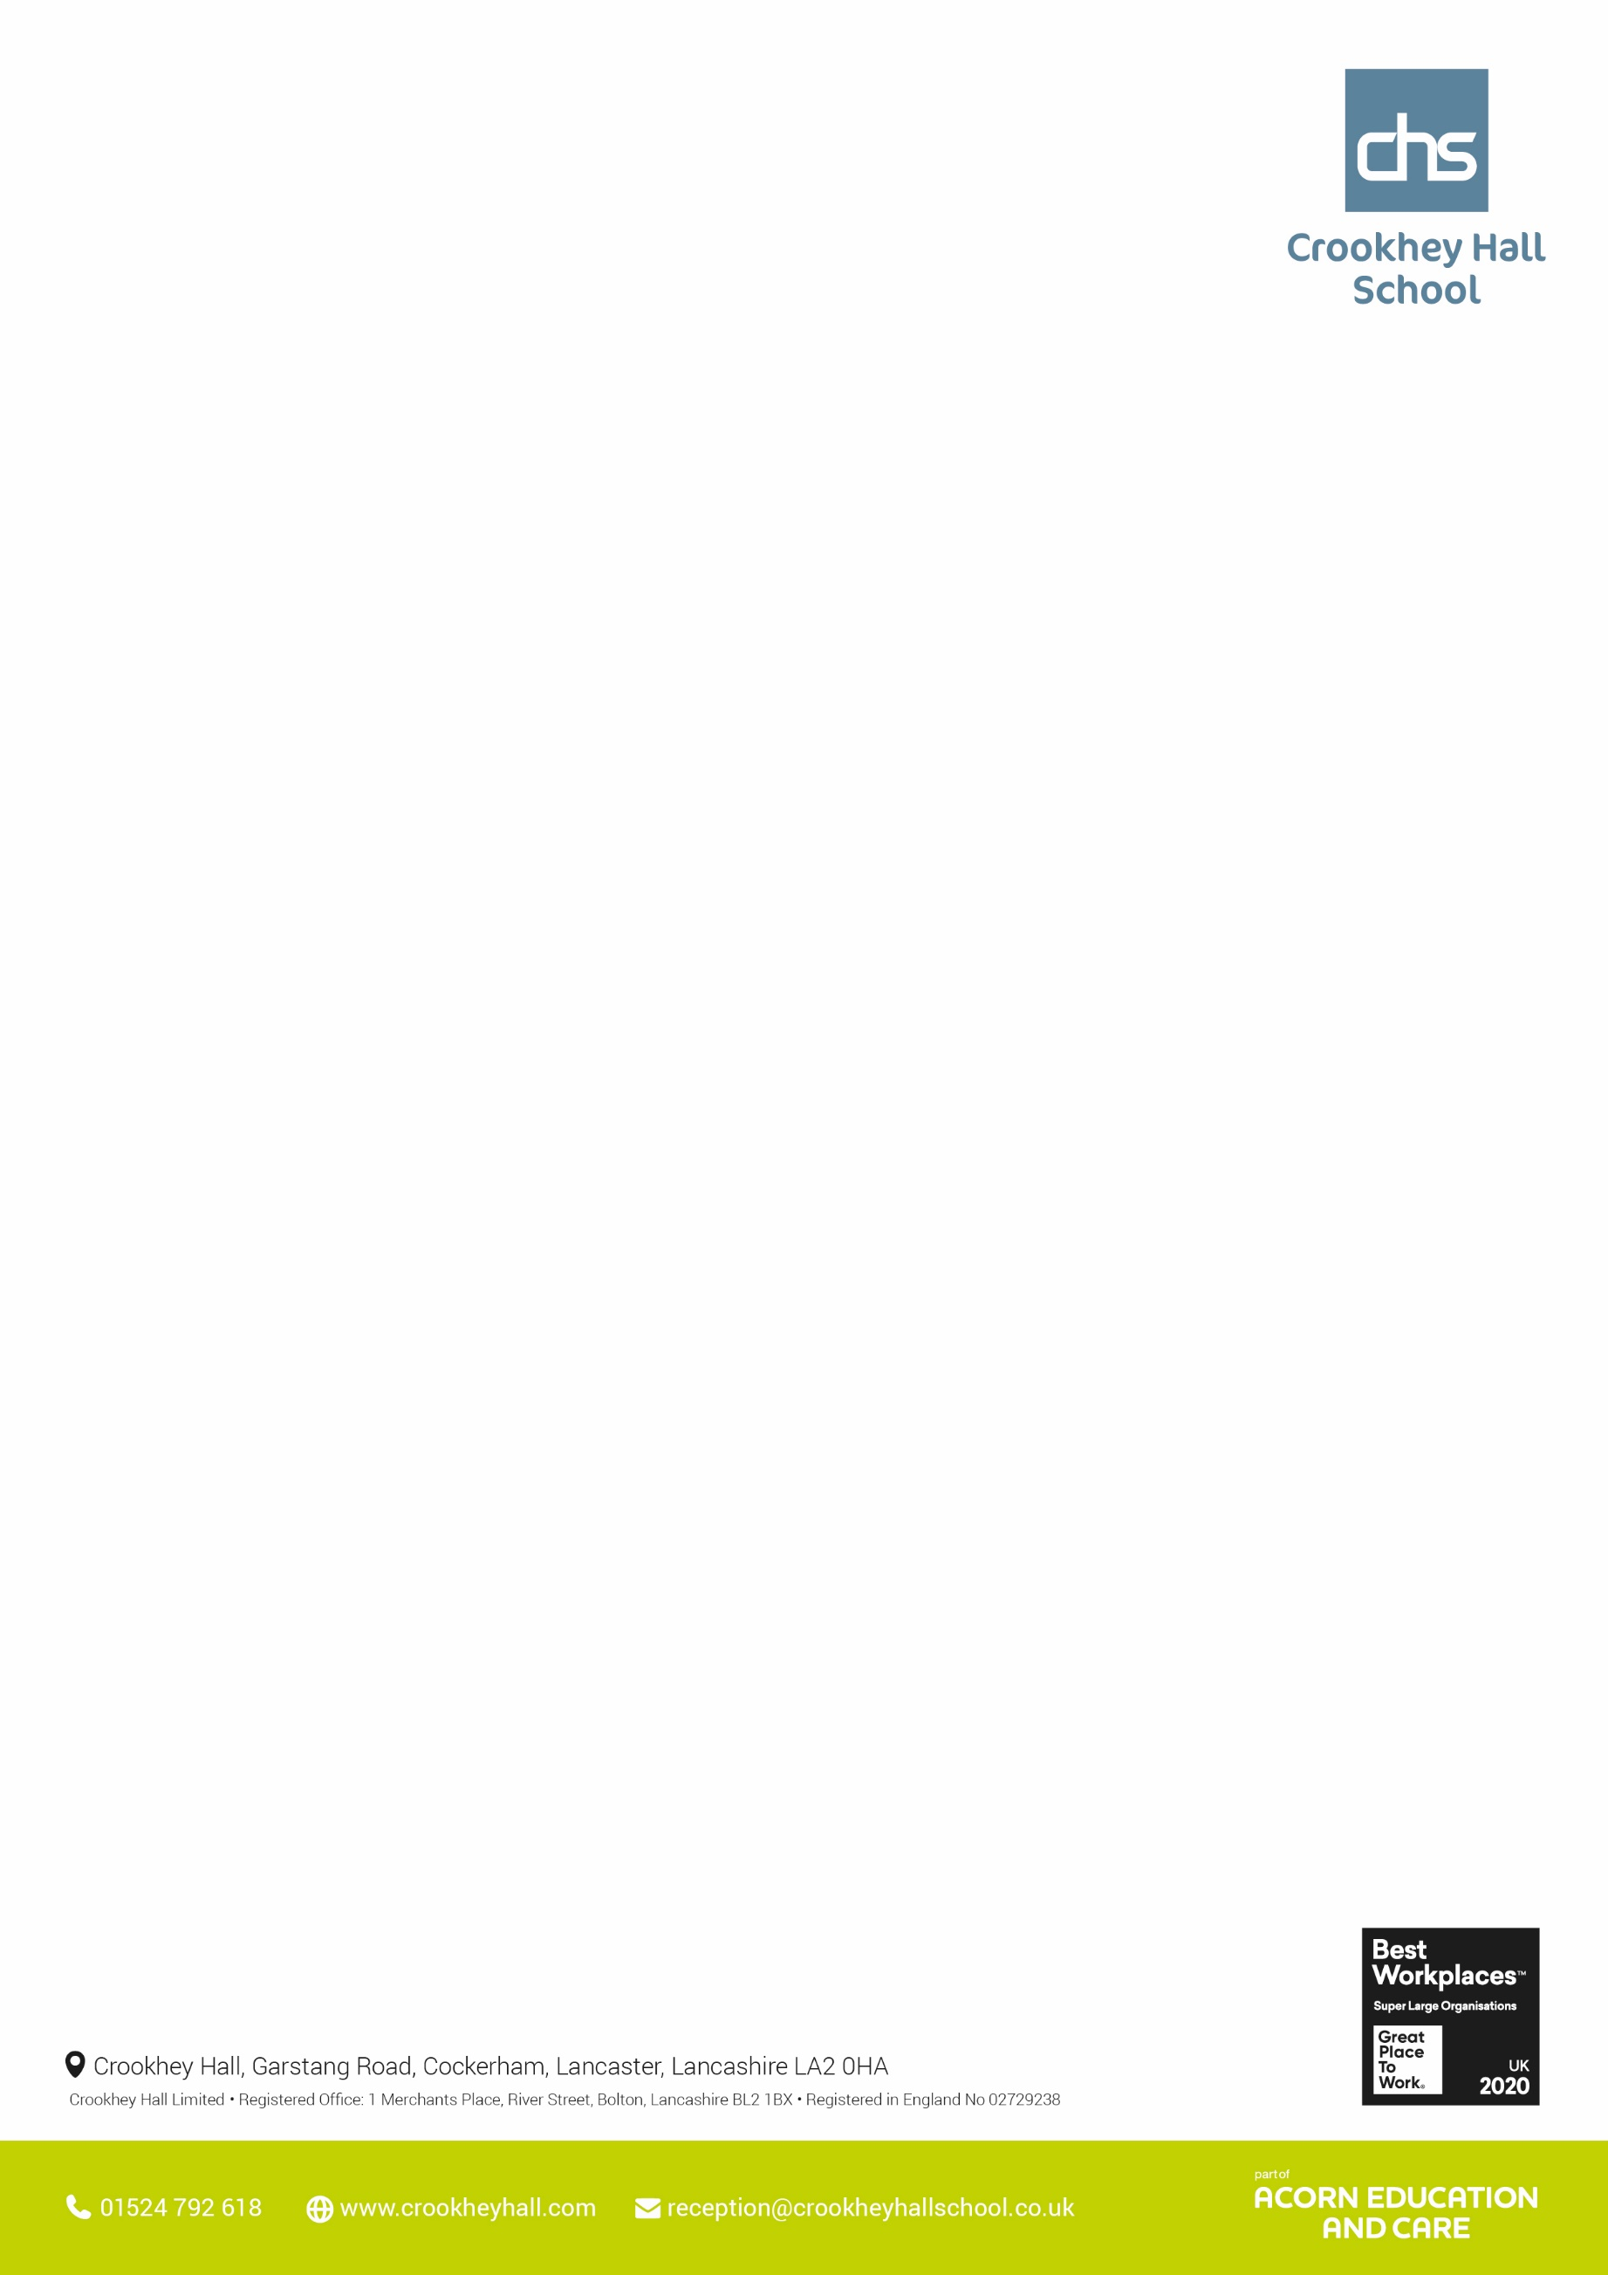

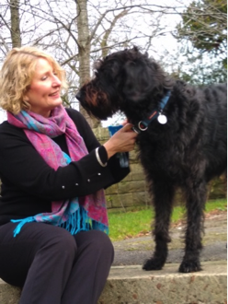

Maths - Class 1 – Entry Level papers, GCSE practice Papers, GCSE Topic papers. Class 2 – GCSE Past Papers, 3D shapes. Class 3 – Entry Level 3 – Line graphs, 3D shapes. Class 4, 5 and 6- End of Topic assessment- Powers and square roots, Number strategies prior knowledge assessment, addition and subtraction strategies. **Science** - Year 10 have been looking at genetic inherited conditions e.g cystic fibrosis and then using online quizzes to review their learning on inheritance.  Class 6 have also moved on to reproduction looking at the difference between sexual and asexual reproduction. Year 11 have been working on finishing their entry level certificate papers and some students are practicing past papers in preparation for their 1st Biology GCSE exam on 16th May.  **English** - **Class 1-** Have analysed a text and considered how the writer used words, phrases, language techniques and sentence structures to convey a sense of conflict. With varying degrees of support, they have begun to produce written responses to the text. **Classes 2,4,5,6** Have used persuasive writing techniques to ‘sell’ their character ideas to Marvel. Some have begun writing the letter, being careful to include the correct layout features of a letter, others have required explicit instruction on how to set out the letter. **Class 3**- Have continued to work through individual literacy units which include work on sentence construction, inferring information from a text and finding information which is clearly stated.

Class 3- Have continued to work through individual literacy units which include work on sentence construction, inferring information from a text an finding information which is clearly stated.

**Thought’s from the Head**

Being in school is important to your child’s achievement, wellbeing, and wider development. Every moment in school counts, and days missed add up quickly, you cannot learn what you are not here to learn.  Please support us by encouraging your child to attend school regularly and report any absences on the morning of the first day of absence.  You can report the absence either directly to the school number or via the text to home service.

If you are struggling with this issue, please let us know, we are here to support.

Have a lovely bank holiday weekend celebrating our new King’s Coronation.

**Pictures from Upper School this week**

**Outdoor Education -** Continuing with BMXing, all taking part and enjoying the sessions led by a professional BMX instructor. **History** this week Year 10 have started their end of unit assessment on The Norman Conquest, completing their second of three ELC History units. **Hair and beauty** - year 10 - we have been learning how to cleanse tone and moisturise before applying makeup.  
year 11 - we have been learning how to style hair using different hair tools for the same hair style. **Art:** Year 11 - These students have finished GCSE Art and are now using this time for English and Maths revision. **Catering** Year 11 - Students created a range of dishes, including curries and stir frys **Land Based Studies and Great Outdoors** - we have been making some new laying boxes for the cream Legbar hens, hoping that we will be able to breed them for their lovely blue-green eggs. **Law** - Starting Police and Their Powers this week in Law.

**ICT** - This week the students have been experiencing virtual reality and discussing how it could be used in education.

**Upper School – Other areas**

**Upper School – Core subjects**

**Wc 1st May 2023**



**Wc 1st May 2023**

**Lower School – Other areas**

**English -** Year 7 have been focusing on Haiku poems. Year 8 have been analysing song lyrics using poetic terms. Year 9 have been considering the term diversity and what it means to them.

**Science -** Year 7 - We have been using the circuit equipment all week, investigating the affects the amount of power packs and lightbulbs have on the circuit. Year 8 - We have continued to look at the atmosphere and how our roles on the planet affect this. We looked at carbon footprint and the layers of the atmosphere. Year 9 - We have been looking at the particle model, and how particles change when they are solids, liquids and gases.

**Maths** - Year 7 - This week year 7 have been looking at converting analogue and digital times and converting to and from the 24-hour clock. Year 8 - This week year 8 have been looking at classifying and estimating angles. Year 9 - This week year 9 have been applying their knowledge of angle rules to find missing angles that are vertically opposite, on a straight line and within a triangle.

**Lower School – Core subjects**

**Pictures from Lower School this week**

**Outdoor Education -** Continuing with BMXing, all taking part and enjoying the sessions led by a professional BMX instructor and continuing with archery sessions for a 5-week course. Engaging very well.

**Art -** Year 7 Art: Students produced freehand drawings inspired by Leonora Carrington and Steve Watts mural at Crookhey Hall School. year 8: Students worked on pencil control and typography, looking at graffiti lettering.

**Catering:** Year 9 Students created a range of dishes, including curries and stir frys

**ICT** - All groups exploring emails and communicating online. Doing worksheets and online activities.